MEMBER
1.AFTER CLICKING ‘ONLINE FILE CLAIMING’ -> GETTING LANDING PAGE
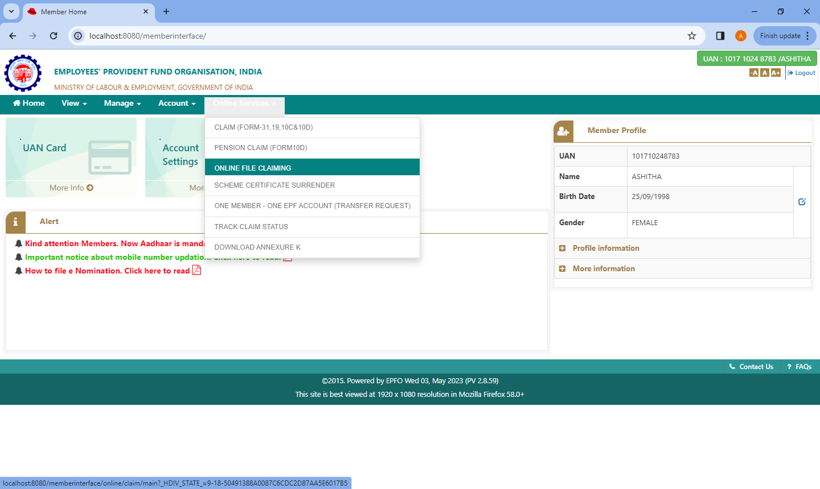
2. AFTER CLICKING ‘PENSION CLAIM(FORM 10D)’ -> GETTING PENSION CLAIM PAGE
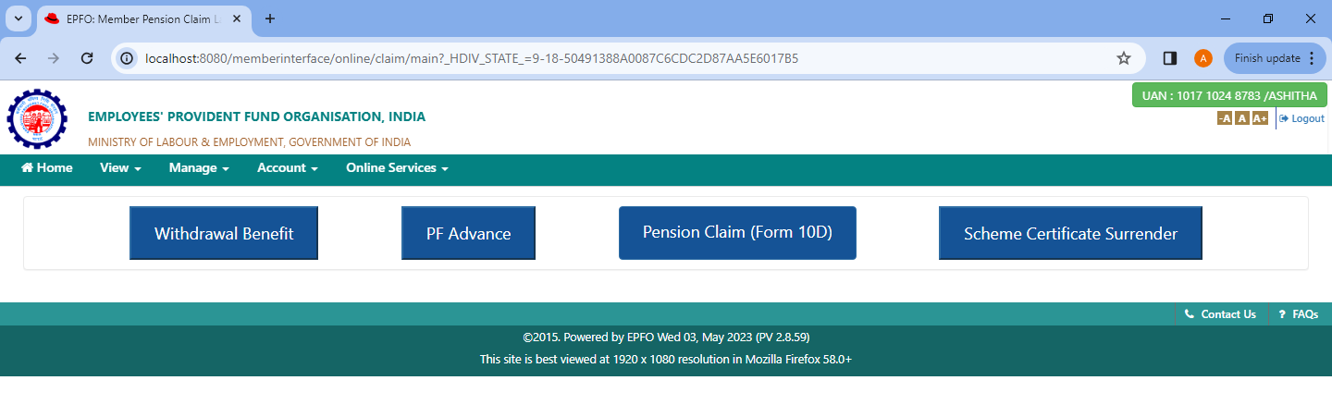

3,4.BEFORE ANY SELECTION
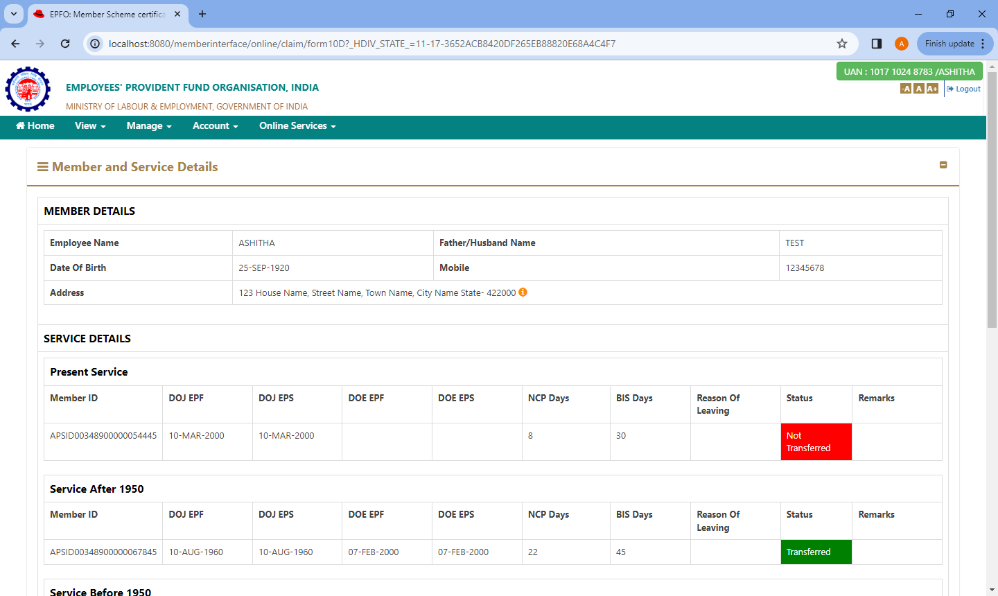
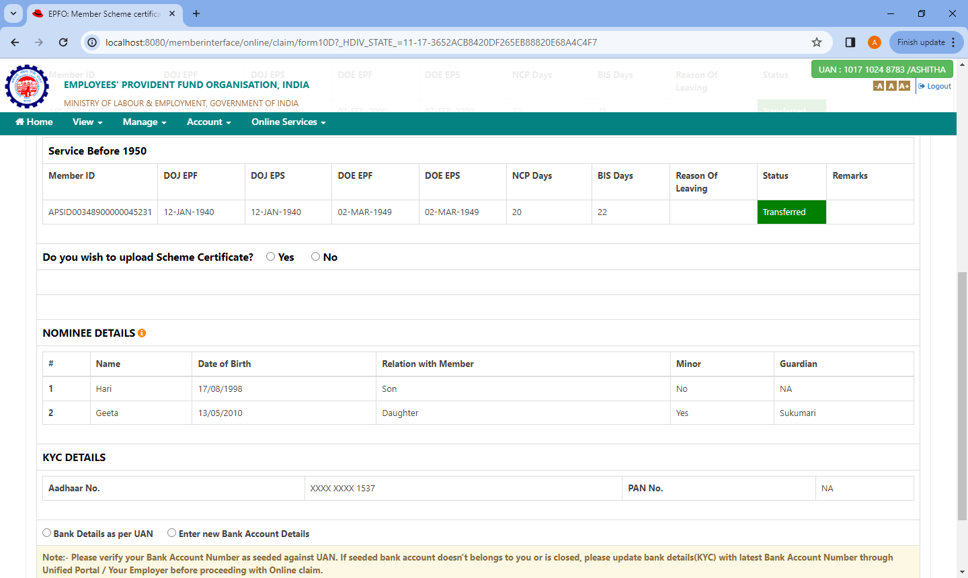

5. SCHEME CERTIFICATE VALIDATION-NOT FILLING ANY DETAILS
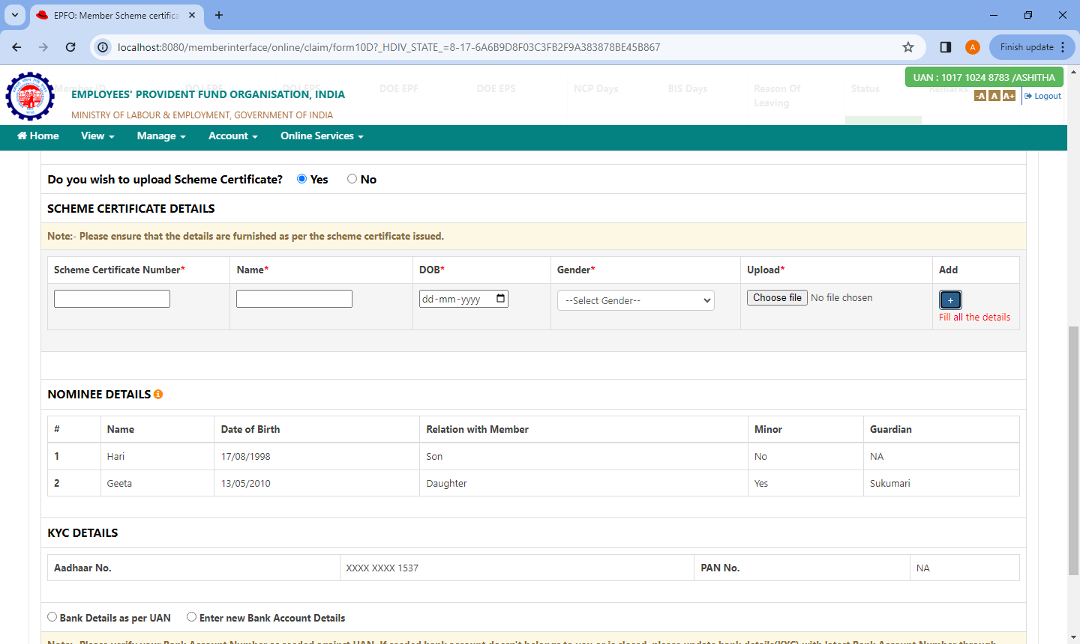
6. SCHEME CERTIFICATE VALIDATION-WHEN ADDING INVALID SCHEME CERTIFICATE NUMBER
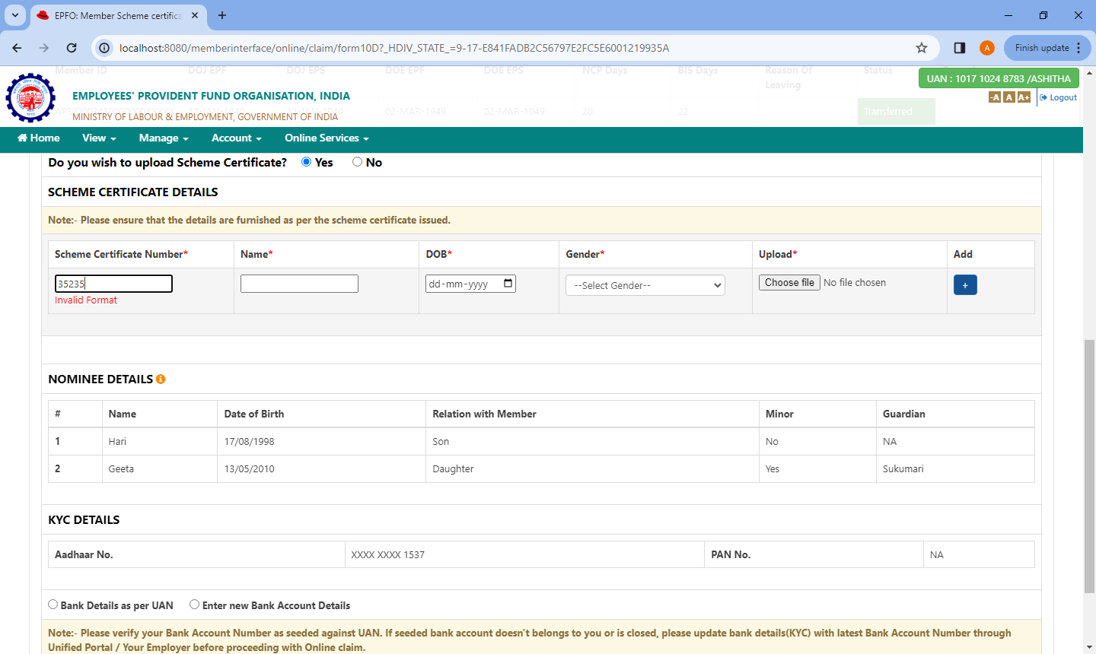

7. SCHEME CERTIFICATE VALIDATION-WHEN ADDING FILES OTHER THAN PDF
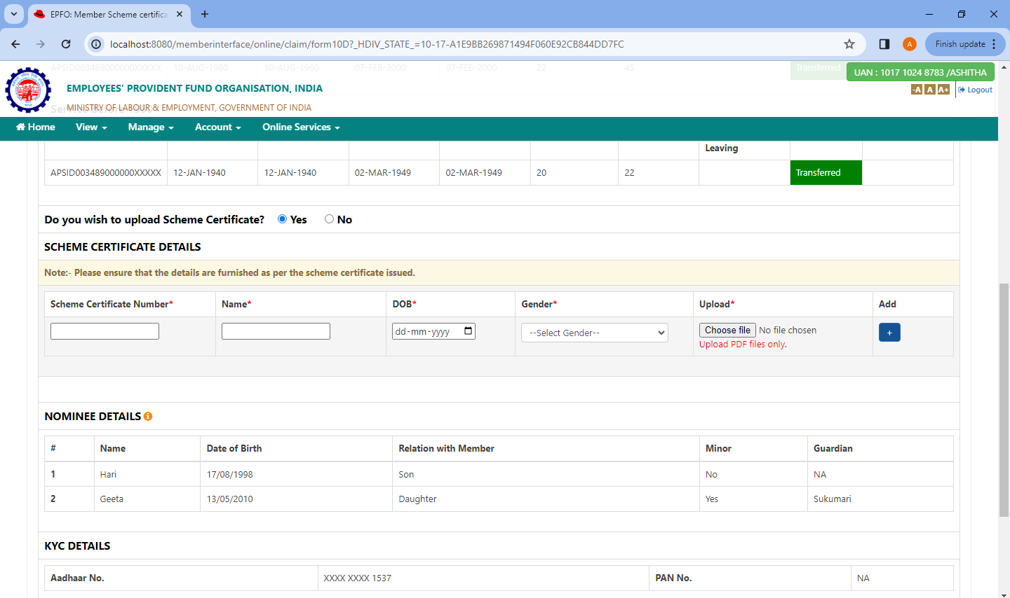
8. SCHEME CERTIFICATE VALIDATION-WHEN ADDING PDF FILE GREATER THAN 2 MB
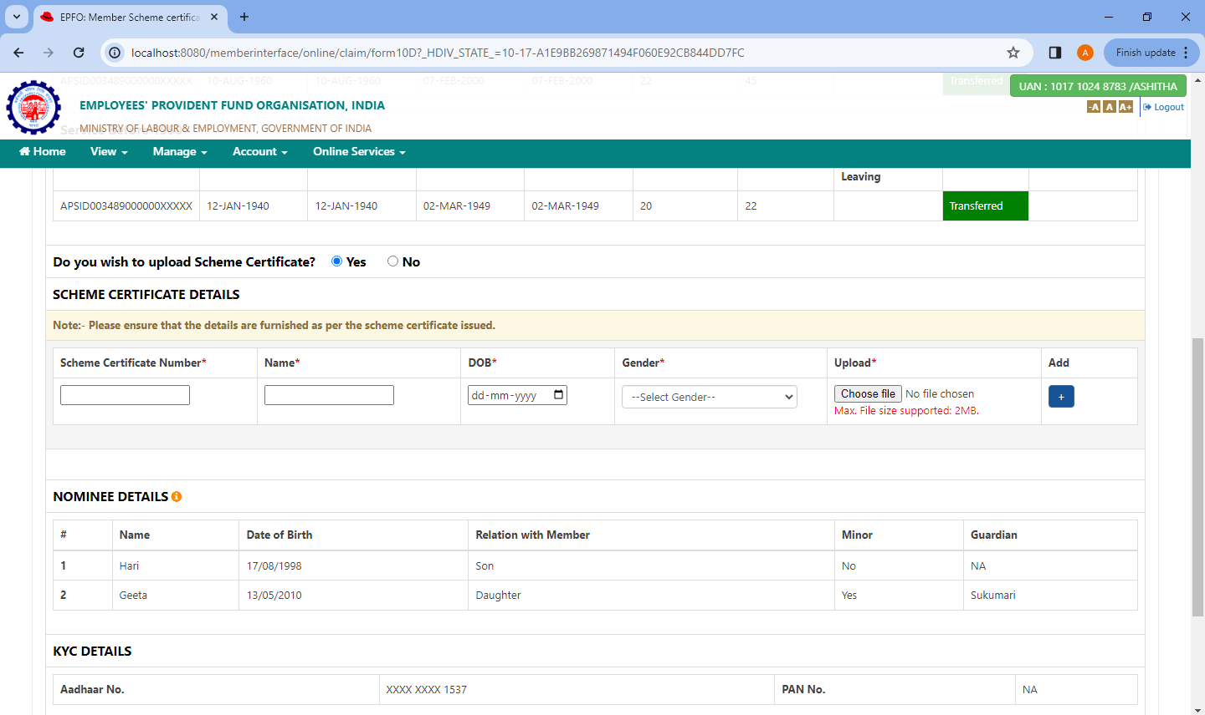
9.AFTER SUBMITTING VALID DATA
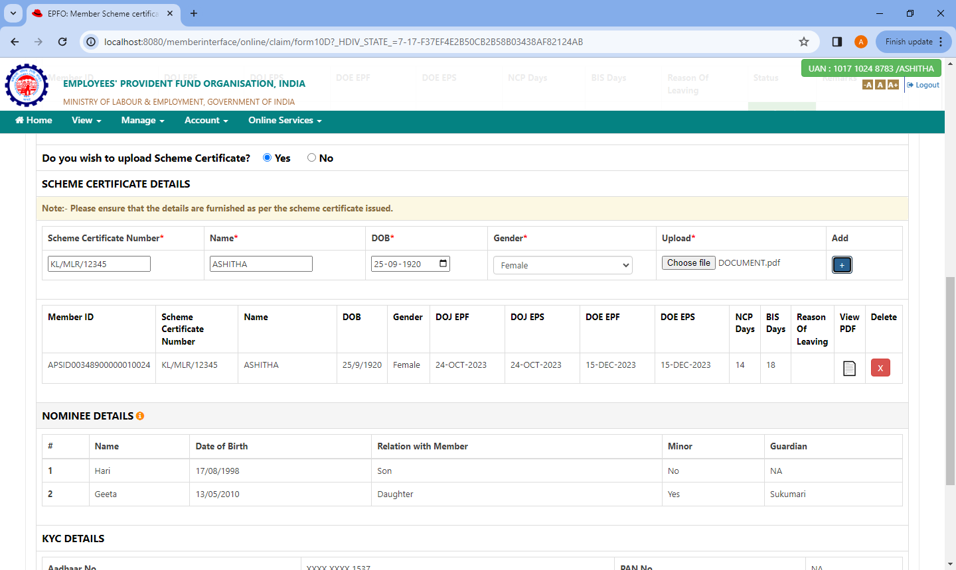
10.WHEN SELECTING ‘BANK DETAILS AS PER UAN’
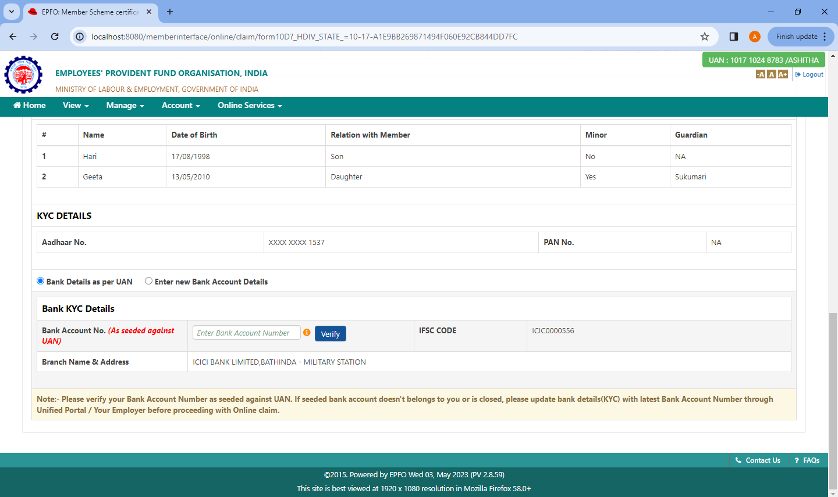

11.WHEN SELECTING ‘ENTER NEW BANK ACCOUNT DETAILS’ AND NOT ENTERING ANY FIELDS
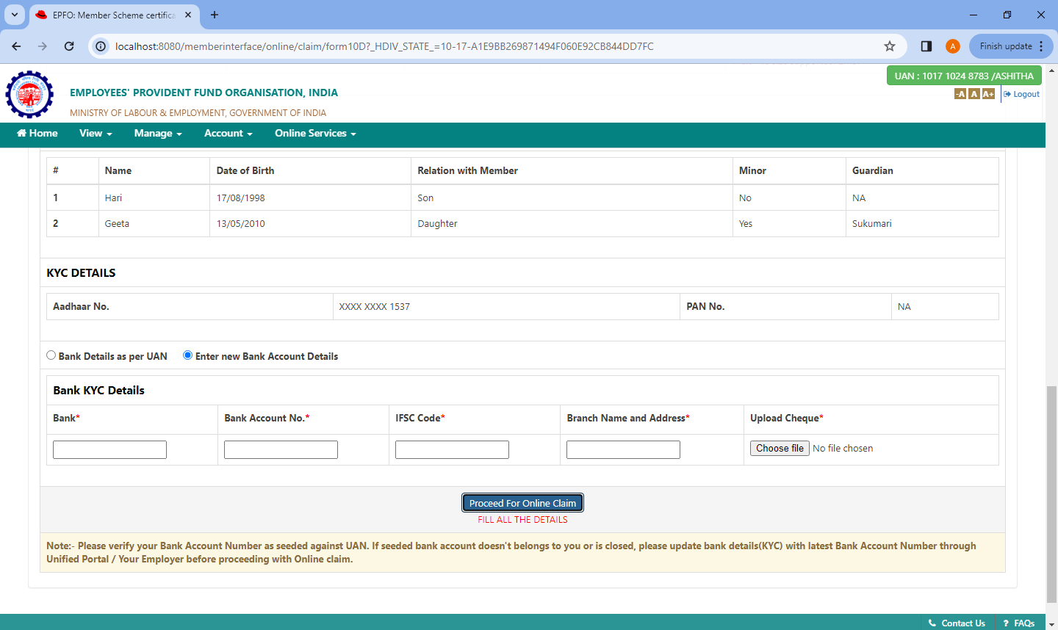
12.AFTER SUBMITTING THE FORM,NEW PANEL SHOWS
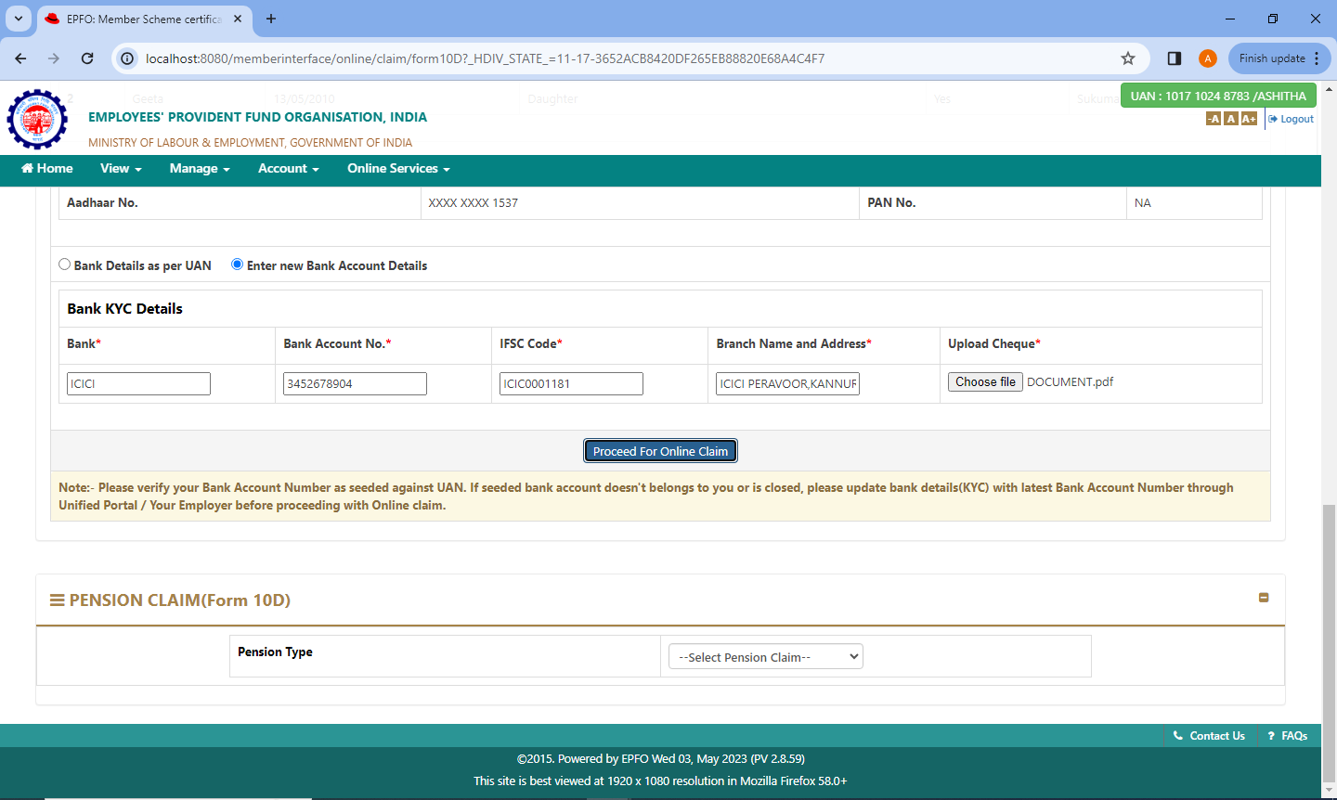
13.AFTER CLICKING ‘DISABLEMENT PENSION’
