Using DBCA to manage database
Modify listener.ora to access with localhost C:\Oracle\product\21c\homes\OraDB21Home1\network\admin

cd C:\Oracle\product\21c\dbhomeXE\bin
Container Database within which pluggable database is created: XE
TDE Wallet Password can be left blank
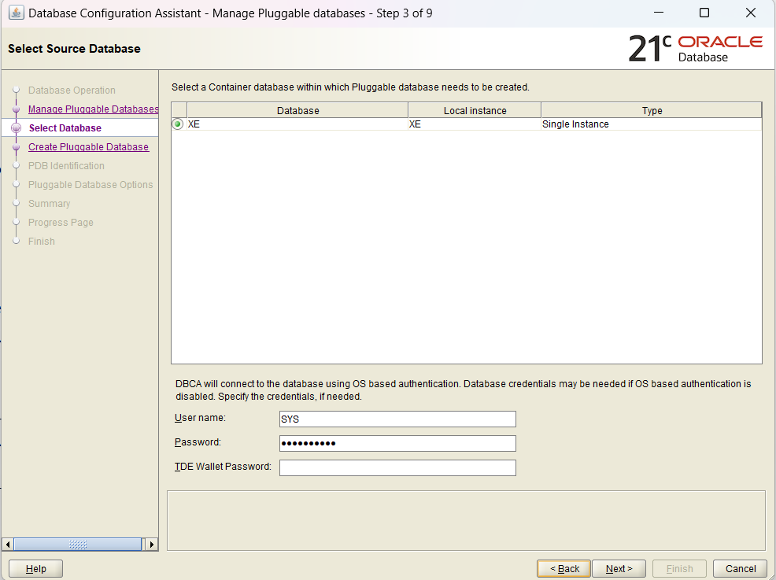

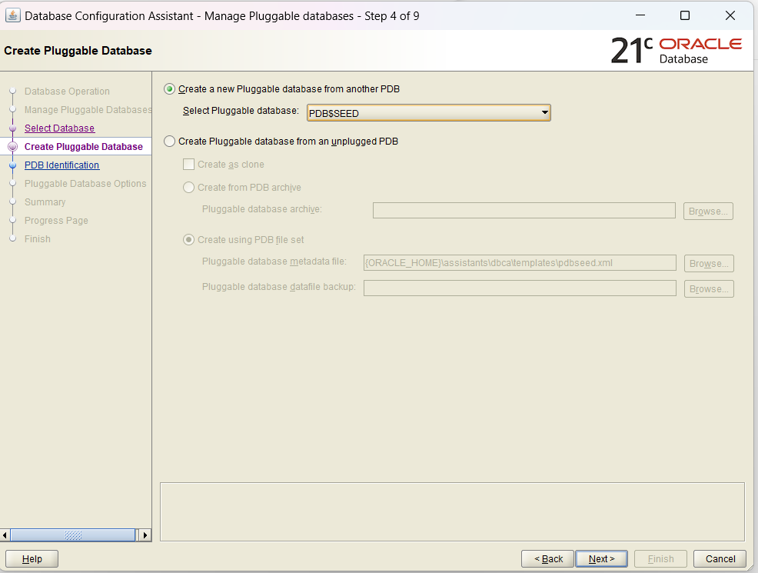

Databasename:anrspdb
Admin User/Password: anrsadmin/*****

To know the service names: (using SQLPlus or Oracle SQL Developer connecting as SYS user)
select PDB, NAME from V$SERVICES;
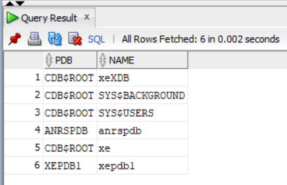
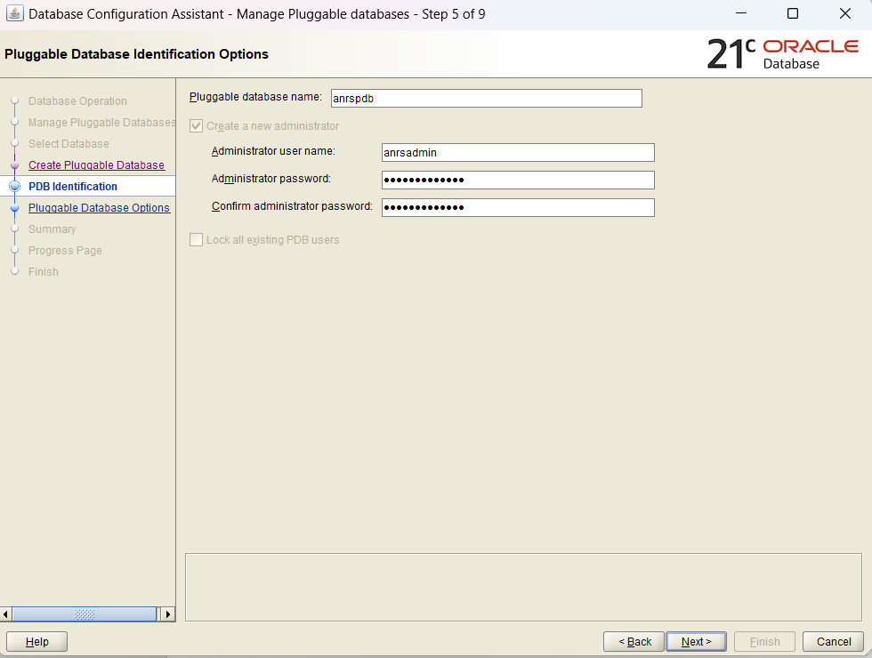

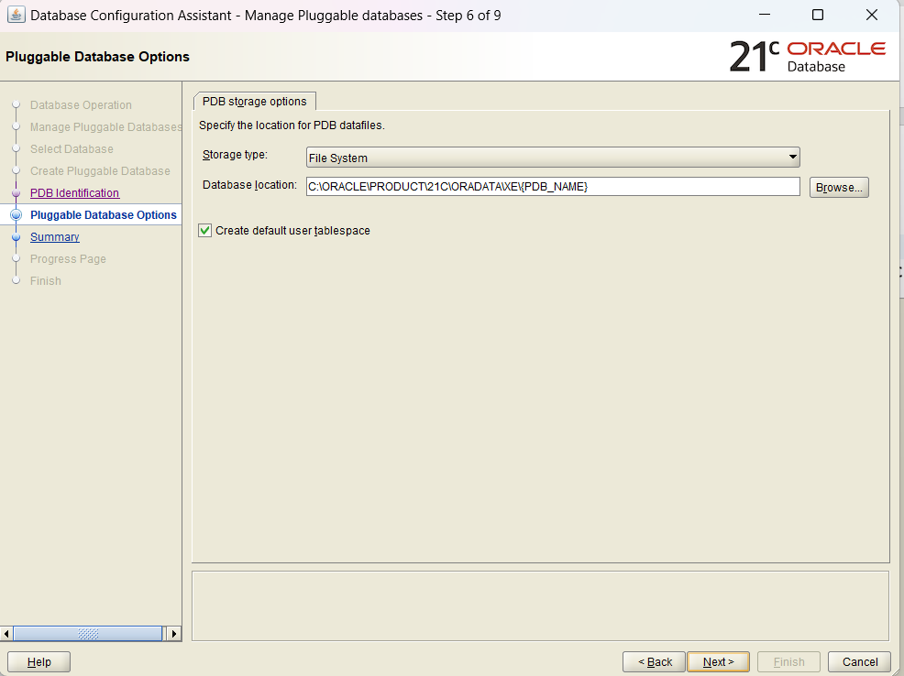

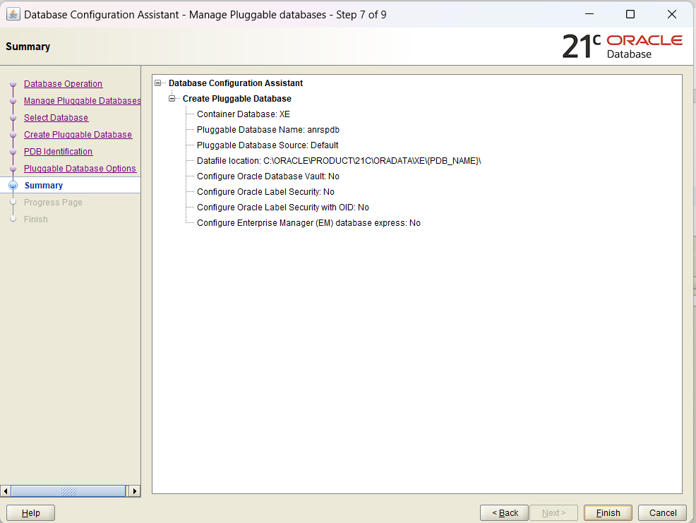

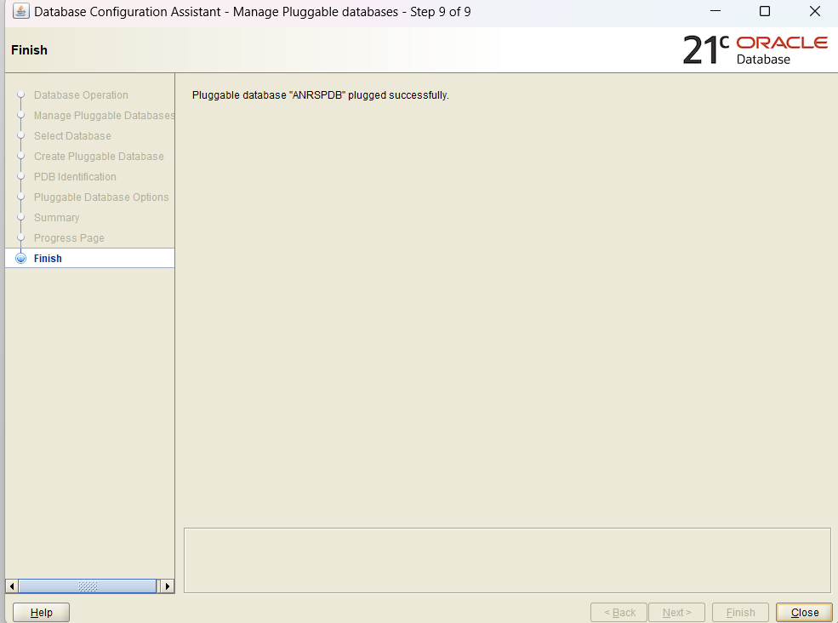

Connecting using SQL Developer
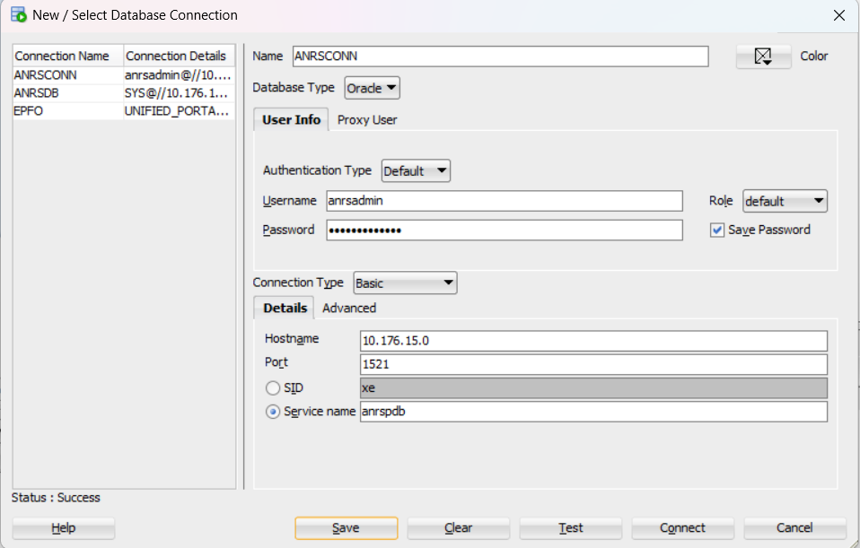

Grant privileges to user using SQLPlus
ALTER SESSION SET CONTAINER = anrspdb

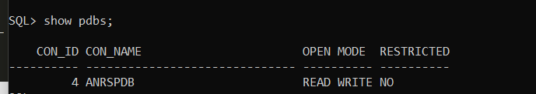
ALTER DATABASE OPEN;

You grant privileges to the anrsadmin user by using the following GRANT statement:
SQL> GRANT CONNECT, RESOURCE, DBA TO anrsadmin ;

Grant succeeded.

We also need to ensure our new user has disk space allocated in the system to actually create or modify tables and data, so we’ll GRANT TABLESPACE like so:

GRANT UNLIMITED TABLESPACE TO anrsadmin;

