Web Cephalometry

- The metric /calibration line should be provided as a separate toggle option. It currently remains visible and interferes with digitization, which affects user experience
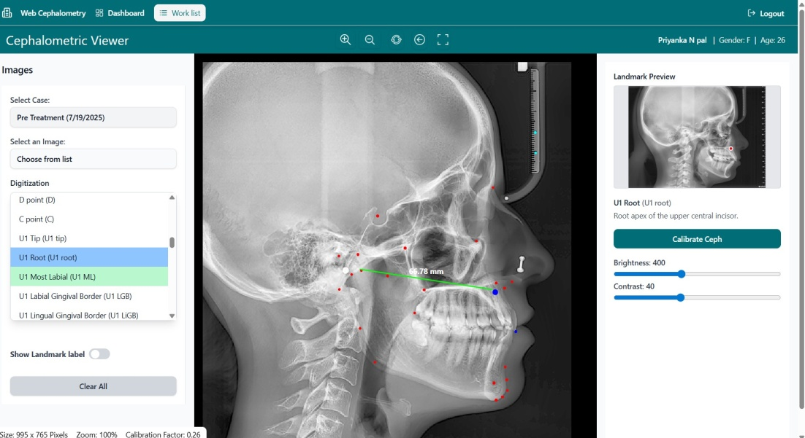

- When placing landmarks, the blue dot (highlighted point) appears too large, this blocks the view of the exact location being marked. This causes difficulty in accurately positioning the point.

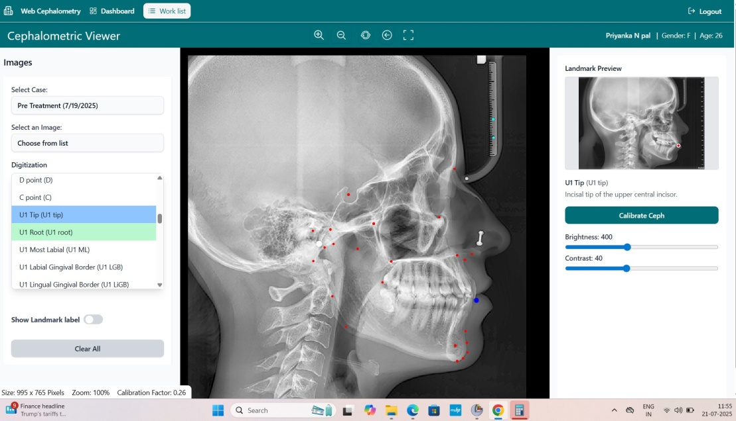

- After uploading, the cephalometric images loads partially, the full image should auto-fit to the viewer window immediately upon loading — without needing any manual adjustment.

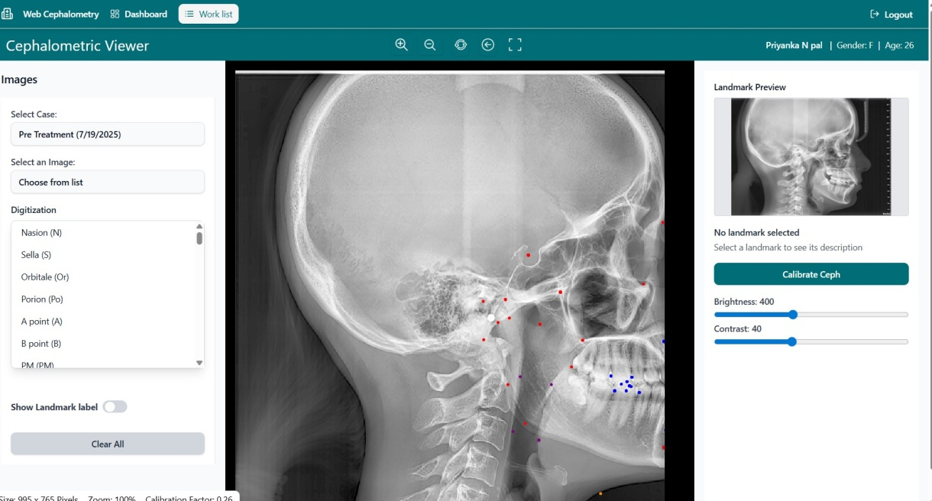

- The definitions need to be corrected and updated based on the Word document shared earlier.

