Introduction

  - Name of the Product
HealthCare Survey App
  - Product Mnemonic
HCSA
  - Definitions
- Survey Module: A collection of questionnaires designed for specific healthcare domains such as Oral Health, NCD, or Child Health.
- App Super User: Owners and publishers of the application, responsible for managing high-level operations.
- Survey Manager: Users who manage specific survey modules and request access to them.
- App Admin: Users responsible for conducting and managing surveys at specific locations.
- Institution Admin (Inst Admin): Users who request surveys for their institution.
- Survey User: Field workers conducting surveys on the ground.
- LSGD: The Local Self-Government Department (LSGD) is a government department in India that oversees and administers local self-government institutions. The LSGD is responsible for implementing programs and policies related to local governance, decentralization, urban development, and rural development.
  - Acronyms
- NCD: Non-Communicable Disease
- HCSA: Healthcare Survey App
- LSGD: Local Self-Government Department
  - Abbreviations
- API: Application Programming Interface
- DB: Database
- JSON: JavaScript Object Notation
  - References

General Description
  - Product Perspective
The Healthcare Survey App is a platform to streamline data collection in healthcare domains, supporting multiple survey modules. It provides a centralized database to store templates and responses, ensuring secure and efficient data management. The application will be published on both the iOS App Store and Android Play Store.
  - Product Functions
- Survey Management: Create, update, and assign surveys across different domains (through pre-defined survey form templates).
- User Management: Registration, approval, and assignment of roles.
- Data Collection: Capture and store survey responses as JSON.
- Data Export: Generate survey data in export formats like CSV, XLS, and PDF.
  - Product Specification
The mobile app will be developed using cross platform development framework Flutter. The back end application will be developed using a REST API with PostgreSQL as the database. The front end will be native iOS (Swift) and Android (Kotlin) applications.
  - User Characteristics
- App Super User: High-level users with administrative rights for app management
- Survey Manager: Users from specific health domains or NGOs.
- App Admin: Location-specific survey conductors.
- Inst Admin: Institutional representatives requesting surveys.
- Survey User: Field workers performing surveys.
  - General Constraints
- Must comply with Digital Personal Data Protection Act 2023 (DPDPA).
- The system requires online data connectivity.
- The location parameters should be designed to ensure compliance across all states within the country. (State – District - LSGD)
  - Standards or Universally Approved Codes of Practice Applicable
- OWASP Security Guidelines
- OWASP Mobile Security Guidelines
  - Risks Identified in the Requirement Phase

The questionnaires may initially be incomplete and require iterative fine-tuning based on feedback received from institutions during actual survey implementation. Template-based form rendering will be designed to dynamically support the creation and customization of survey forms.
  - Assumptions and Dependencies
- Internet connectivity is available during data collection.

Specific Requirements
  - Functional Requirements

    - User Registration and Management

      - Introduction
The app must support registration workflows for five user categories: App Super User, Survey Manager, App Admin, Inst Admin, and Survey User. The locations are mapped through parameters State, District and LSGD.
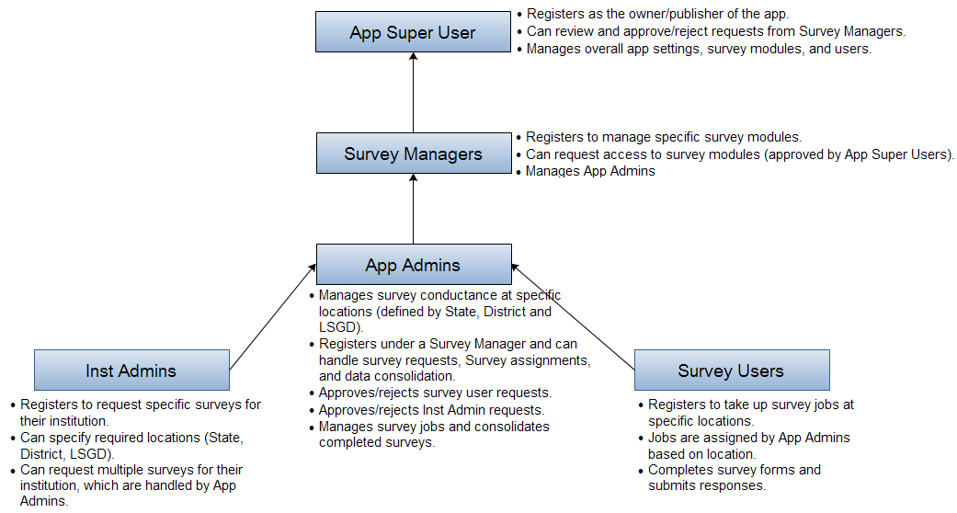
App Super User | - Registers as the owner/publisher of the app.  - Can review and approve/reject requests from Survey Managers.  - Manages overall app settings, survey modules, and users.
Survey Manager | - Registers to manage specific survey modules.  - Can request access to survey modules (reviewed by App Super Users).  - Manages App Admins
App Admin | - Manages survey conductance at specific locations (defined by State, District and LSGD).  - Registers under a Survey Manager and can handle survey requests, assignments, and data consolidation.  - Approves/rejects survey user requests.  - Manages survey jobs and consolidates completed surveys.
Institution Admin | - Registers to request specific surveys for their institution.  - Can specify required locations (State, District, LSGD).  - Can request multiple surveys for their institution, which are handled by App Admins.
Survey User | - Registers to take up survey jobs at specific locations.  - Can specify required locations (State, District, LSGD) while registration  - Jobs are assigned by App Admins based on location.  - Completes survey forms and submits responses.
      - Inputs
- User details (e.g., name, institution, email, mobile number, location).
- Role-specific information (e.g., survey module preferences, location hierarchy).
      - Processing / Conditioning
- Validate user inputs.
- Store user data in the database.
- New user request notification for approvers (e.g., App Super Users, Survey Managers).
- Approval notification to requesters
      - Outputs
- Confirmation of registration.
- Approval/rejection notifications.
    - Survey Management

      - Introduction
Users must be able to create, assign, and manage surveys and jobs.
Survey Modules | - The app will allow capture of data for different survey modules such as Oral Health, NCD, and Child Health Surveys.  - Each survey module will contain a set of questionnaire templates stored in a central database as JSON format.
Survey Templates | - Each questionnaire in a survey module will have a corresponding template JSON stored in the database for rendering the questionnaire in the app.
Survey Responses | - Responses to survey questions will be captured as JSON data and stored centrally.
Survey Request Process | - Institution Admins request surveys by providing survey-specific details (Survey Module, state, district, LSGD, etc.).  - App Admins review and approve/reject these requests, assign survey jobs to Survey Users, and consolidate completed survey data and forward the survey data to Institution Admins
      - Inputs
- Survey template JSON.
- Location details (state, district, LSGD).
- Expected completion date.
      - Processing / Conditioning
- Assign surveys to App Admins and Survey Users.
- Monitor job progress.
- Consolidate survey results.
      - Outputs
- Survey Data in CSV, XLS, or PDF format.
  - External Interface Requirements
    - User Interfaces
- Mobile app for iOS and Android.
- Web based interface for users to download survey data
- Web based dashboard for App Super Users.
    - Hardware Interfaces
- Devices must support iOS 13+ and Android 8+.
    - Software Interfaces
- REST API for communication between the app and server.
  - Performance Requirements
- Must support a pre-defined number of concurrent users.
- API response time must be within acceptable limits.
  - Design Constraints
    - Standards Compliance
- Should follow OWASP guidelines for secure API development.
    - Hardware Limitations
- Requires a server machine with required configurations
  - Attributes
    - Security
- Encrypt all data in transit and at rest.
- The system to undergo security audits for both the app and web application.
    - Maintainability
- Modular design to support future enhancements.
- Dynamic survey form rendering for accommodating new survey modules or for customization of existing survey forms. The JSON schema for survey templates in Annexure B.
  - Other Requirements
    - Database
- PostgreSQL schema attached as Annexure A.
    - Operations
- Regular database backups.
    - Site Adaptation
- Should adapt to locations with low connectivity.
- Web application to be hosted in SDC to ensure application availability.

Annexure A: Database Design

Annexure B: Survey Form Template

