Dashboard

1. Create a tabbed dashboard with option for selecting state and district, selecting a time period, refresh button,

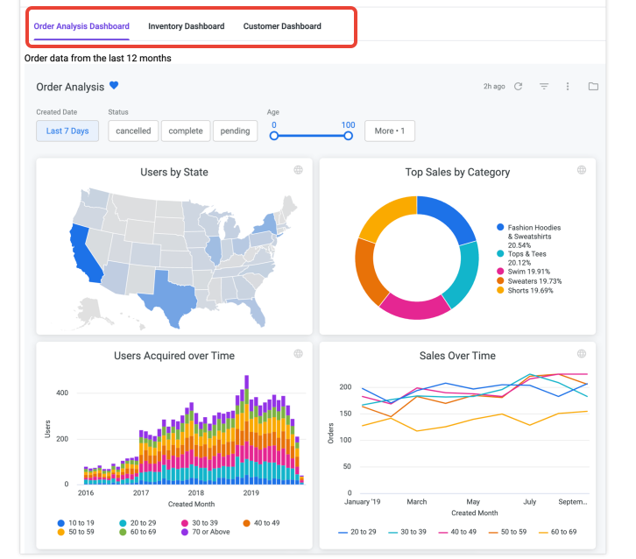

2. Plot the following graphs by fetching data from backend.
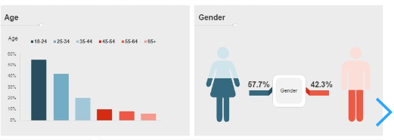
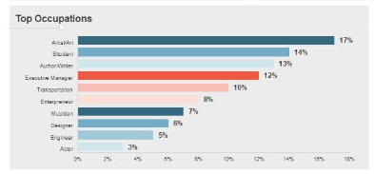

A visual representation of data that describes the population of a country, such as age, gender, income, education, and place of living
Spain Example - The dashboard is using Spain as an example country.
Split by Gender, Age, Income, Education, Place of Living - The dashboard shows data for each of these categories.
Gender - The percentage of the population that is male or female.
Age - The distribution of the population by age group.
Income - The distribution of the population by income level.
Education - The distribution of the population by education level.
Place of living - The distribution of the population by place of residence.
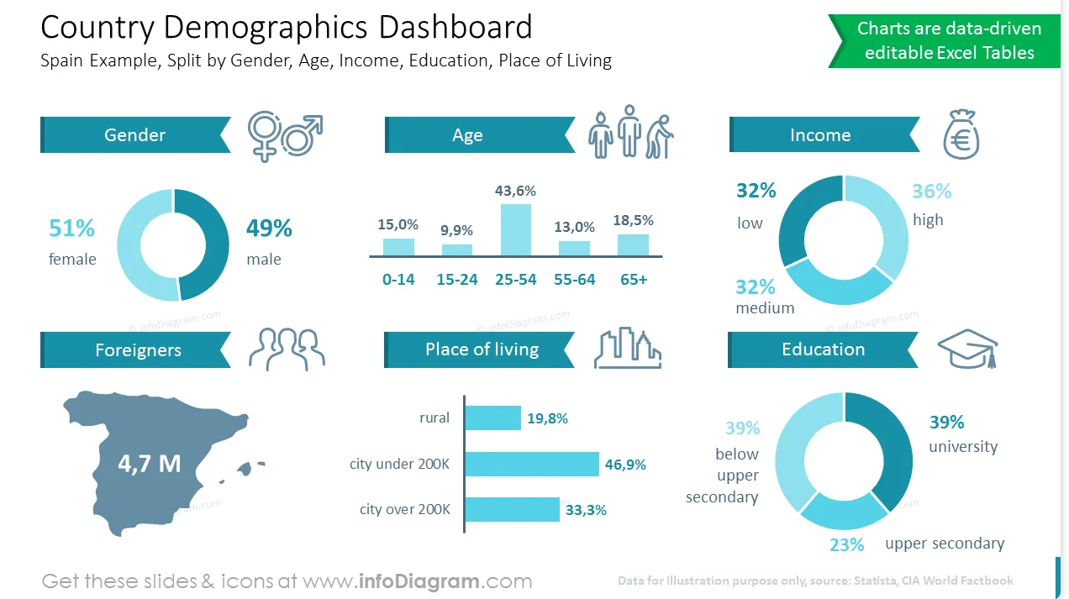
3. Scatter maps for the selected area for user-selectable fields such as
- Electrification
- Water source
- Waste disposal
- Latrine
- Sewage
- Sullage
See some examples from https://www.slingshotapp.io/en/help/docs/analytics/data-visualizations/visualization-types/scatter-map/scatter-map

- Survey Completed(house,members,family)
  - Partially
  - Fully

- Electrification =>Yes/No
- Drinking Water Souce
  - Piped Water into Dwelling
  - Piped water to Yard/Plot
  - LSGD Watersupply
  - Public Tap
  - Own Well- Protected
  - Own Well-Unprotected
  - Rainwater
  - Tanker Truck
  - SurfaceWater(River/Dam/Lake/Pond/Stream/Canal/Springs)
  - Bottled Water
  - Community RO Plant
  - Public Well
  - Public Borewell
  - Private Borewell
  - Tube Well
  - Handpump

- Waste Disposal
  - Dumping
  - Burial
  - Burning
  - Composting
  - Biogas Plant
  - Collected by Agency
  - No method

- Is Domestic water safety=>Yes/No
- Latrine
  - Connected to Sewerage System
  - Connected to Septic Tank
  - Connected Flush to Pit Latrine
  - Drain to Water Bodies
  - Drain to Other Places
  - Pit Latrine with Slab
  - Open Pit Latrine
  - Ventilated Pit Latrine
  - Biogas Toilet
  - Twin Pit / Composting toilet
  - Dry Toilet
  - No Facility / Open Space / Field
- Sewage
  - Soakage pits
  - Connected to Sewerage System
  - Drainage to outside drain
  - Drainage to water bodies
  - Open Drainage
- Sullage
  - Soakage pits
  - Connected to Sewerage System
  - Drainage to outside drain
  - Drainage to water bodies
  - Open Drainage

- Cooking fuel
  - LPG
  - Bio-Gas
  - Fire Wood
  - Electricity
  - Charcoal
  - Kerosene
  - Dung Cakes
  - Straw / Grass / Coconut Shell / Coconut Husk
  - Rice Husk/Sawdust
  - No Cooking
- Animal Pet Information =>yes/No
- Occupation
  - Occupied – Own
  - Occupied – Rental
  - Permanently Locked
  - Temporary Shelter

- Smoking
  - Smokes daily
  - Occasional smoking
  - Stopped(<1 year)
  - Stopped(> 1 year)
- Present Health Issues
  - Diabetes Mellitus
  - Hypertension
  - Congenital Heart Disease
  - Coronary Artery Disease
  - Chronic Respiratory Disease
  - Cancer
  - Chronic Kidney Disease
  - Sickle Cell Anaemia
  - Haemophilia
  - Psychiatric Disorder
  - Epilepsy
  - Stroke
  - Alzheimers Disease
  - Parkinsonism
  - Tuberculosis
  - Thyroid disorder
  - HIV
  - Hepatitis A
  - VDRL
  - Leprosy
- Disability
  - Locomotor Disability
  - Serious Visual impairment
  - Blindness
  - Deafness
  - Autism
  - Leprosy sequelae
  - Speech disorder
  - Mental retardation
  - Mental disorder
  - Learning Disorder
  - Muscular dystrophy
  - Chronic neurological disorder
  - Multiple sclerosis
  - Kyphosis-scoliosis
  - Dwarfism
  - Haemophilia
  - Thalassemia

