Doc. Name | DETAILED DESIGN DOCUMENT
Project | Development of eHealth Mobile Application for Public Health
Doc. No. | DDS HT 052 0001 | Section/Group
Control Status* | DRAFT | Copy No.**

Functional designation of approving authority |  | Functional designation of issuing authority
For any clarifications/corrections/amendments in this document please contact issuing authority

Issue History
Issue No. | Effective From(Date) | Reason for Re-issue | Total Doc. Pages | Date of consolidation of review outputs
1 | _ _ / _ _/ _ _ _ _ | NA | 21 | _ _ / _ _/ _ _ _ _

Approved By:___________________
(Functional designation) Date of approval: _ _ / _ _/ _ _ _ _
Notes:
* Mark control status as “Controlled Copy if read from version control system” in document maintained as softcopy.
** “Copy No” field needs to be filled only when hard copies of the document are distributed as controlled copies. In such cases, mark control status as “Controlled” and Copy No as serial numerals: ex: 1, 2, 3 etc.

Copyright
No part of this document may be reproduced in any form without the prior permission in writing of issuing authority

CONTENTS
1. Introduction 5
1.1. Name of the Product 5
1.2. Product Mnemonic 5
1.3. Definitions 5
1.4. Acronyms 5
1.5. Abbreviations 6
1.6. References 6
1.7. General Constraints 6
1.8. Standards or universally accepted codes of practice applicable 6
1.9. Risks, if any, identified in the preliminary design output phase 6
2. Theory, Principle of Working and Calculations 6
2.1. eHealth Application for Public Health System (PHS) 7
2.1.1. The Architecture 7
2.1.2. Technology 9
2.1.3. Application Components 10
3. System Architecture 11
4. Hardware Environment 12
5. Software Environment 12
6. Module Detailed Design – eHealth PHS Flutter App 12
6.1. User Authentication 15
6.1.1. Hardware 15
6.1.2. Software 15
6.1.3. Mechanical 17
6.2. Home Page 17
6.2.1. Hardware 17
6.2.2. Software 18
6.2.3. Mechanical 18
6.3. Field Survey 18
6.3.1. Hardware 18
6.3.2. Software 18
6.4. Member Survey 24
6.4.1. Hardware 24
6.4.2. Software 24
6.4.3. Mechanical 25
6.5. Grouping Survey - Family 26
6.5.1. Hardware 26
6.5.2. Software 26
6.5.3. Mechanical 27
6.6. Grouping Survey – Ration Card 27
6.6.1. Hardware 27
6.6.2. Software 27
6.6.3. Mechanical 28
6.7. Relations 28
6.7.1. Hardware 28
6.7.2. Software 28
6.7.3. Mechanical 29
6.8. Application Boarding 29
6.8.1. Hardware 29
6.8.2. Software 29
6.9. Device Logging 30
6.9.1. Hardware 30
6.9.2. Software 30
7. Module – eHealth PHS Web API 31
7.1. Data Synchronization 31
7.2. Module – APIs for OTP handling 45
7.2.1. Hardware 45
7.2.2. Software 45
7.2.3. Mechanical 46
7.3. Module – Retrieving Institution information for user 46
7.3.1. Hardware 46
7.3.2. Software 46
7.3.3. Mechanical 47
Annexure – 1: Application Source files 48
Annexure – 2: Class Diagrams 52
Annexure – 2: Web API Backend development environment setup 52
Annexure – 3: Database Design – Offline mobile DB in SQLite 52
a. ph_house_survey 52
b. ph_member_survey 60
c. ph_family_survey 85
d. ph_member_relation 90
e. ph_menus 98
Sample Data 98
f. ph_roles 98
g. ph_menu_role 99
h. ph_app_vers 99
i. ph_login_log 102
j. ph_user_mpin 104
k. ph_user 104
l. ph_ashablocks 105
m. ph_ashablock_housemapping 106
n. ph_ashablock_assign 107
o. ph_ashablock_ashamapping 108
p. ph_sync_rec 109
q. ph_sync_error_log 109
Annexure : Integration with Centralised Aadhaar Vault 111
Annexure ABHA Number and Address Generation 111
Annexure: Keycloak Identity and Access Management (IAM) Request and Response formats 113

- Introduction

This document provides a conceptual design for the development of eHealth Mobile Application for Public Health. The project aims for the design and development of a mobile app and backend services to efficiently manage public health survey and health care services offered to public. The document identifies and explains important architectural elements. This document will serve the needs of stake holders to understand the application system concepts.

  - Name of the Product

eHealth PHS mobile app

  - Product Mnemonic

eHealthPHS

  - Definitions

  - Acronyms
MVVM | Model View ViewModel
API | Application Programming Interface

  - Abbreviations

Nil

  - References

  - General Constraints

(Including Applicable Statutory and Regulatory Requirements)

Nil

  - Standards or universally accepted codes of practice applicable

(other than Centre QMS)

Nil

  - Risks, if any, identified in the preliminary design output phase

[Include (a) the risk event and (b) the potential consequences if left unmanaged. Preferably add (c) root cause of the issue]

Nil

- Theory, Principle of Working and Calculations

The project has two main modules
- eHealth Mobile Application for Public Health System (PHS)
- Web APIs for backend services to store/synchronize public health data from the mobile app to backend database system

The eHealth PHS App will be developed as an offline-first application and will be designed to work even without an internet connection. Once the device has an active internet connection, the data from local mobile DB upload synched to central PHS DB. There will be a two-way data synchronization approach:
- Upload data synchronization: Push data from device to central PHS
- Download data synchronization: Pull data from central PHS to device local DB

  - eHealth Application for Public Health System (PHS)

    - The Architecture

The development of eHealth PHS mobile app will be following a Model — View — ViewModel (MVVM) architecture to ensure clean and structured code and software maintenance. MVVM is the industry-recognized software architecture pattern that overcomes the drawbacks of MVC design patterns. MVVM separates the data presentation logic (Views or UI) from the core business logic part of the application. The functions of various layers are described below:

Model | The Model in the MVVM design pattern represents the actual data (real-time) which will be used in application development. Model can only reflect the actual data, not the characteristics or any feature related to the application. This layer is responsible for the abstraction of the data sources. Model and ViewModel work together to retrieve and store the data.
View | The purpose of this layer is to inform the ViewModel about the user’s action. This layer observes the ViewModel and UI component widgets reside here. This element utilizes a set of libraries to present the data more accurately and appropriately.
ViewModel | It exposes those data streams which are relevant to the View. Moreover, it serves as a link between the Model and the View. The most essential element of MVVM architecture is ViewModel, which presents the View part separately from the Model. The ViewModel also possesses access to the methods, function calls, and other factors that can help to maintain the actual state of the View.

The figure 1 below depicts the different layers in MVVM architecture.
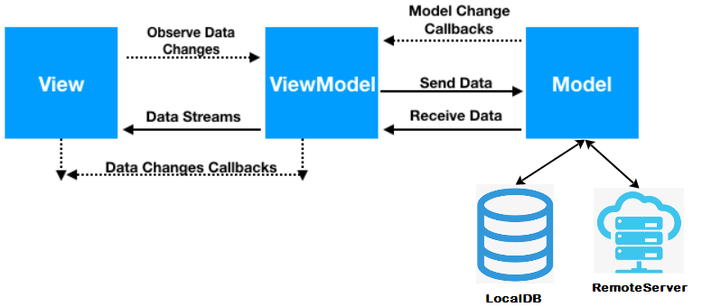
Figure 1: MVVM Architecture Layers

    - Technology

The proposed eHealth PHS mobile app will be developed using Flutter SDK and DART programming language. The existing screen forms of eHealth Public Health Tablet application will be re-designed and re-coded using Flutter widgets and data modeling and data query interfaces will be re-designed and re-coded as per new database schema design provided by eHealth PMU. The auto-complete feature will be implemented for selection from a long list of values using specific Flutter widgets. The new application will have a single code base for Android and iOS platforms and will have a responsive design to support different screen sizes. The SQLite will be the database used for storing public health data and database design provided by eHealth PMU will be used. The sensitive data in eHealth public health database will be encrypted using suitable encryption algorithms in Flutter. Push notifications will be implemented to alert users on updates. The software / libraries used for the development are
- Flutter SDK
- Dart Langauge
- Dart Packages (pub.dev)
- SQLite mobile database / sqflite_sqlcipher
- Firebase/OneSignal for Push notifications
- Flutter Flow for screen prototyping

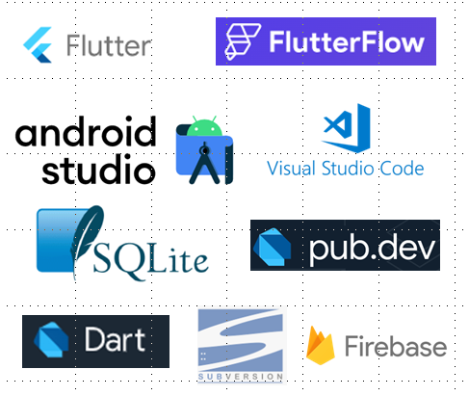
Figure 2: Technologies for development
    - Application Components

The application will have the following functionality components
- Login
- Home Page
- House Survey
- Family Member Survey
- Family Grouping
- Ration card grouping
- Relation grouping
- View and Edit (Survey)
- Control of Non Communicable Diseases (NCD)screening
- Control of Non Communicable Diseases (NCD) registration
- Control of Non Communicable Diseases (NCD) follow-up
- Control of Non Communicable Diseases (NCD) out-of-area registration
- View and Edit (NCD)
- Integrated Disease Surveillance Programme(IDSP)
- Eligible Couple (EC) Registration and Follow-up
- Immunization – Out Reach
- Immunization – elsewhere
- Immunization - AEFI
- Immunization – out-of-area
- Antenatal Care (ANC) Services Registration
- Antenatal Care (ANC) Services Follow-up
- Antenatal Care (ANC) Services Outcome
- Antenatal Care (ANC) Services Dashboard
- Postnatal Care (PNC) Services – Maternal
- Postnatal Care (PNC) Services – Neonatal
- View and Edit (Immunization, EC, ANC, PNC, Birth, Death)
- Birth Registration
- Death Registration
- Event reporting (Rumor register)
- Village Survey

- System Architecture

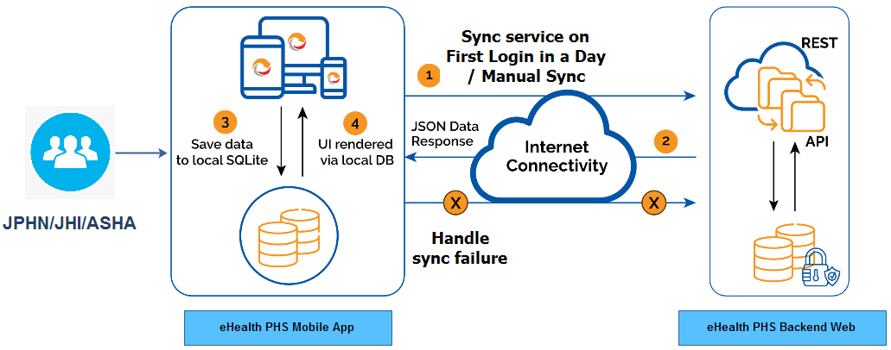

Figure 3: System Architecture

- Hardware Environment

The following is the minimum hardware environment to be setup for the design and development of the application. Deployment scenario for testing requires Android and iOS platform mobiles
Processing Units | Intel(R) Core(TM) i5 @ 2.9GHz
RAM | 8 GB minimum of RAM to run application. 16GB memory is recommended for Android Studio simulator
HD Storage | 500GB
Internet | Required for flutter package upgrade and also for testing data sync testing

- Software Environment

The following table defines the software requirements for the proposed architecture of the software.
Software | Description
Operating system (OS) | Windows 10+ operating system.
Flutter SDK | Rendering technologies for web pages and DZI image viewers
Flutter plug-ins/packages | Various flutter plugins for SQLite, http client, network info etc. from pub.dev
Dart | Business logic implementation
Flutter Flow | Screen prototyping tool for Flutter
SQLite | Local mobile DB
PostgreSQL Database server | An open source database for holding health survey and service data

- Module Detailed Design – eHealth PHS Flutter App

As per the MVVM architecture, the application code is structured into three folders – presentation, domain and data. The presentation folder corresponds to the View and ViewModel layers of the MVVM architecture. The domain and data contributes to the model layer of the MVVM architecture.

The presentation folder has dart files for UI part and for mapping data through web APIs or SQLite DB to UI elements. The data and domain folders will have dart files for the modelling of data and data handling through web service APIs or local SQLite database.

There is a folder common for keeping all dart files which defines variables and functions which are to be accessed from different layers of the application. This include SQLite data connection objects, singleton class repositories, logging objects and other constant parameters related to web service URLs or DB connection parameters.

Folder structure of application source code

Folder Name | Description
common | This folder has dart files with classes for shared variables and functions which are accessed from various layers throughout the application.
presentation | This folder is part of View and ViewModel layers of Model-View-ViewModel architecture. This folder contains UI, View Objects and components. This directory is again split for different features. Folder for each feature will hold dart files for view (UI) and view models. The folder common will keep dart files which define base classes used by the dart files in the presentation folder (view and view model layer). The folder flutter_flow contain dart files for defining themes/styles used by the Flutter Flow screen prototyping tool being used for the UI screen development. This files for this folder will be the files downloaded from Flutter Flow tool.
domain | This folder is part of Model layer of Model-View-ViewModel architecture. This folder will contain use cases, domain objects/models, and repository interfaces. The use cases will have modules for accessing device handling features like camera, location, network connectivity check etc. The actual implementations for these features will be in presentation/common/ folder.
data | This folder is also part of Model layer of Model-View-ViewModel architecture. This folder will contain local SQLite DB APIs, data objects (API request/API response object and DB objects), and the repository implementation

Since the app has a large number of pages and has various data models to deal with, the source files needs to be organized in a consistent way. A feature-first approach will be used in organizing the application source files. In feature-first approach, inside each layer folder, sub folders will be created for each feature. We create directories for layers and separate folders will be created for features.

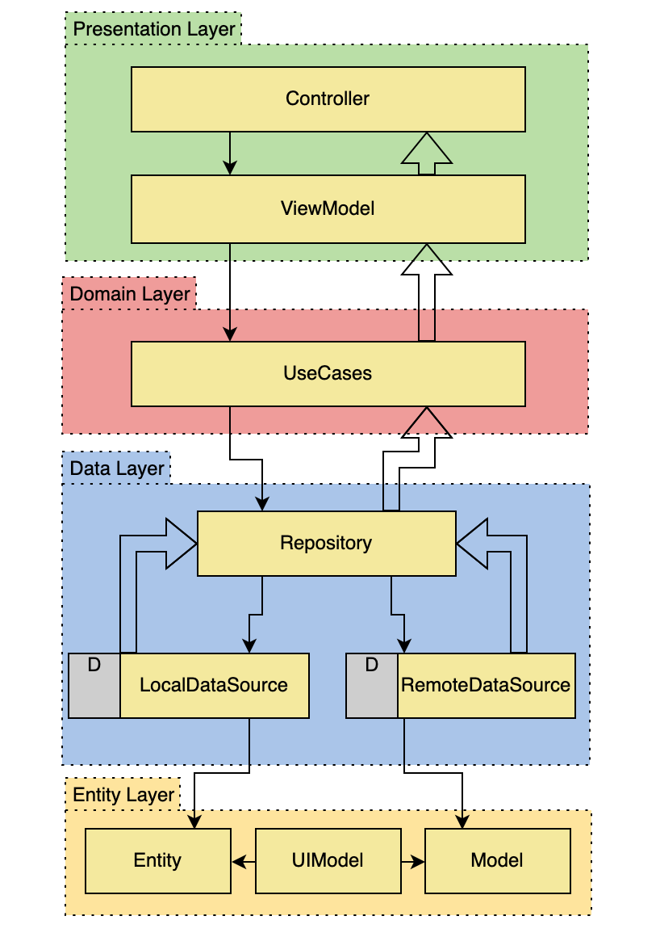
Figure 4: Flutter MVVM Code flow

  - User Authentication
    - Hardware

Not Applicable
    - Software
      - Description – Module

The users for eHealth mobile app will be authenticated in both online way and offline way. The first access to the mobile app in a day will be authenticated in an online way. Online connectivity is required for the first access to the app in a day. After a successful user authentication in a day, the users will be allowed access to the app through MPIN based authentication in an offline way for subsequent logins in the same day. The online authentication is required in the following cases:
- First login in a day
- First login after an application upgrade
- When the user changes the device
- When the institution associated with the user changes (when the user gets transferred to another institution)

The online authentication after the following events will use 2-factor authentication (an OTP sent to the registered mobile number of the health worker and a password)
- First login after an application upgrade
- When the user changes the device
- When the institution associated with the user changes (when the user gets transferred to another institution)

The module will perform the following
Online authenticate
Offline authenticate with MPIN
Handle Device ID Change

        - Sub Module – Online authenticate
- Inputs

- Process

API end points

Error Handling

- Outputs

- Database
Description on tables involved (Device database)

        - Sub Module – Offline authenticate
- Inputs
- Process
- Outputs
- Database
        - Sub Module – Device Change
- Inputs
- Process
- Outputs
- Database

        - Sub Module – Forgot Password
- Inputs
- Process
- Outputs
- Database

        - Sub Module – Logout
- Inputs
- Process
- Outputs
- Database

      - User Interface

      - Communication Interface
    - Mechanical

Not Applicable

  - Home Page
    - Hardware

Not Applicable
    - Software
      - Description – Module
The module will perform the following
Online authenticate
Offline authenticate with MPIN
        - Sub Module – Dashboard
- Inputs
- Process
- Outputs
- Database
        - Sub Module – Main Menu
- Inputs
- Process
- Outputs
- Database
        - Sub Module – Drawer Menu
- Inputs
- Process
- Outputs
- Database

        - Sub Module – Location Information
- Inputs
- Process
- Outputs
- Database

      - User Interface
      - Communication Interface
    - Mechanical

Not Applicable

  - Field Survey
    - Hardware

Not Applicable
    - Software
      - Description - Module

The module will capture data on various accommodation premises such as houses, hostels, orphanages, jail and so on. The health workers will be visiting various accommodation facilities and capture various details. Those data will be entered through mobile app, stored in local database and later upload synched to central PHS server.

The module does the following.
- New data capture, edit and view.
- Facility to select/view a set of basic parameters
- Option values in drop down boxes to be accessed from lookup list items in database
- Facility to capture GPS location of the house;
- Define new format for House IDs
- Facility to delete house based on the mentioned condition. The condition is, deletion should happen only if no members are in that house.
- Store data in SQLite database.
- Logging transaction data
- Web service APIs for synchronization to central database
        - Sub Module – Add House Survey

- Inputs

Data from House Survey form.

The following are the mandatory data values for House survey
- In-mates type
- LSG Number
- House name
- occupancy status
- number of members
- type of locality
- Electrification Status
- Well

- Process

Class Diagram – House Survey
Included in file housesurvey_classdiagram.svg

The following describes steps followed for the implementation of save functionality for the House survey form.
  - Create screen prototyping in Flutter Flow. Download .dart file and keep under /presentation/housesurvey folder. The file name convention to follow is <featurename>_view.dart
  - Create a <featurename>_viewmodel.dart file and keep under /presentation/housesurvey folder. This creates streamcontroller, stream and sink objects for the view elements for state management
- Include statement in /presentation/resources/routes_manager.dart for defining navigating routes.
Ex: static const String houseSurveyRoute = "/housesurvey";
case Routes.houseSurveyRoute:
initHouseSurveyModule();

initHouseSurveyModule is defined in the centralized class factory /presentation/resources/di.dart

- Define function initHouseSurveyModule () in di.dart. Here the application uses flutter GetIt package for service locator implementation and to have a centralized registry for getting class instances.
Ex:
initHouseSurveyModule() {

if (!GetIt.I.isRegistered<HouseSurveyUsecase>()) {
locator.registerFactory<HouseSurveyUsecase>(() => HouseSurveyUsecase(locator()));
locator.registerFactory<HouseSurveyViewModel>(() => HouseSurveyViewModel(locator()));
}
}

- From <featurename>_viewmodel.dart file, implement functions to call usecase functions for house survey save functionality. The housesurvey_viewmodel.dart does the following
- Create a HouseSurveyObject encapsulating data for house survey form. Here the application uses a flutter package freezed to auto-generate code for some commonly needed functionality such as cloning an object, to string methods and pattern-matching and so on. The command flutter pub run build_runner build --delete-conflicting-outputs can be run in terminal to auto generate code for the classes. Those objects will be placed in presentation/<feature>/dataobjects folder.
- Declare streamcontrollers, sink and streams for managing data flow to and from UI corresponding to different events.
- Call functions of different <feature>_usecase classes for event handling such as save house survey form, or get data for lookup lists.
- Define model classes encapsulating the house survey data for the application domain. The model class will usually map the record structure in respective database table. Model classes will be in /domain/<feature>/model/ folder.
Ex. /domain/housesurvey/model/
- Define usecase classes in /domain/<feature>/usecase/<feature> _usecase.dart.
- Create housesurvey_usecase.dart. This file can have multiple use case classes corresponding to different use cases for the form. Ex. There can have a use case class for saving house survey form, another use case class for getting details for a house.
- Create HouseSurveyUsecaseInputs which is a class for encapsulating data for the user case class
- HouseSurveyUsecase extends an abstract class BaseUseCase which is a class with generic In, Out objects and defines an execute method to return a success or error object. Here a flutter plugin either_dart is used for error handling and this ensures that every function function in Repository returns either a success or failure.
- Define an execute method in each usecase class overriding the BaseUseCase and this invokes functions in Repository classes to perform operations or to fetch data by using remote services or local SQLite DB.
Ex:
@override
Future<Either<Failure, HouseSurveyData>> execute(HouseSurveyUsecaseInputs input) async {
return await _repository.saveHouseSurveyDtls(HouseSurveyRequest(input.id, input.wardId, input.houseName,input.pincode));
}

- Define a repository abstract class in /domain/<feature>/repository/repository.dart and subclass implementation for this base class will go to /data/<feature>/repository/repository_impl.dart. The idea behind Repository pattern is to abstract the data layer. The repository can gather data from different data sources (different REST APIs, cache, local database storage) and it provides this data to the rest of the app. The other components need not know where the data comes from. Repository serves as a mediatory between viewmodel and sources of data.
- Create /data/<feature>/repository/repository_impl.dart with instances of various sources of data such as for remote API or local DB. The methods on respective data source objects are called for handling data through remote web service APIs or SQLite DB APIs.
Ex:
class RepositoryImpl extends Repository {
RemoteDataSource _remoteDataSource;
LocalDBDataSource _localDBDataSource;
}
- Create request classes and response classes for data retrieval or storing through remote service APIs or SQLite DB APIs. The flutter plugin json_annotation which can auto generate code for json serialization/deserialization for request and response classes. The request and response classes for each feature goes to the folders /data/<feature>/request and /data/<feature>/responses.

- To handle data through SQLite DB data source:
- Create data\<feature>\data_source\db_data_source.dart and define methods to access through a SQLite DB client class object of LocalDBClient for data storing or retrieving.
- Create class LocalDBClient in data\<feature>\localdb\localdb_api for executing SQLite queries to fetch/insert/update to SQLite databases. This class uses sqflite which is an SQLite plugin for flutter.
- To handle data through remote service data source:
- Create data\<feature>\data_source\remote_data_source.dart and define methods to access through web service client class object of AppServiceClient for data storing or retrieving.
- Create class AppServiceClient in data\<feature>\network\app_api for executing web service APIs to fetch/insert/update to remote databases. This class uses retrofit which is http client plugin for flutter.

- Outputs

House survey data to store in SQLite Database and synchronize data to central system.

- Database

Database objects to be designed for holding required data and these tables will be used while synchronizing data to central server.

        - Sub Module – View and Edit House Survey

- Inputs
- Process
- Outputs
- Database

        - Sub Module – House Search

- Inputs
- Process
- Outputs
- Database

        - Sub Module – House Delete

- Inputs
- Process
- Outputs
- Database

        - Sub Module – Data synchronization API interface
- Inputs
- Process
- Outputs
- Database

      - User Interface

      - Communication Interface

Nil
      - Mechanical

Not Applicable

  - Member Survey
    - Hardware

Not Applicable
    - Software
      - Description – Module

The module will perform the following

        - Sub Module – Add new member
- Inputs
- Process
- Outputs
- Database

        - Sub Module – View and Edit member
- Inputs
- Process
- Outputs
- Database

        - Sub Module – Member list
- Inputs
- Process
- Outputs
- Database

        - Sub Module – Delete member
- Inputs
- Process
- Outputs
- Database

        - Sub Module – Transfer member

- Inputs
- Process
- Outputs
- Database

        - Sub Module – Data synchronization API interface
- Inputs
- Process
- Outputs
- Database

      - User Interface
      - Communication Interface
    - Mechanical

Not Applicable

  - Grouping Survey - Family
    - Hardware

Not Applicable
    - Software
      - Description – Module

The module will perform the following

        - Sub Module – Add new family
- Inputs
- Process
- Outputs
- Database

        - Sub Module – Modify family
- Inputs
- Process
- Outputs
- Database

        - Sub Module – Delete family
- Inputs
- Process
- Outputs
- Database

        - Sub Module – Family List
- Inputs
- Process
- Outputs
- Database

        - Sub Module – Data synchronization API interface
- Inputs
- Process
- Outputs
- Database

      - User Interface
      - Communication Interface
    - Mechanical

Not Applicable

  - Grouping Survey – Ration Card
    - Hardware

Not Applicable
    - Software
      - Description – Module

The module will perform the following

        - Sub Module – Add new ration card
- Inputs
- Process
- Outputs
- Database

        - Sub Module – Modify ration card
- Inputs
- Process
- Outputs
- Database

        - Sub Module – Data synchronization API interface
- Inputs
- Process
- Outputs
- Database

      - User Interface
      - Communication Interface
    - Mechanical

Not Applicable

  - Relations
    - Hardware

Not Applicable
    - Software
      - Description – Module

The module will perform the following

        - Sub Module – Family listing
- Inputs
- Process
- Outputs
- Database

        - Sub Module – Add relation
- Inputs
- Process
- Outputs
- Database

        - Sub Module – Delete relation
- Inputs
- Process
- Outputs
- Database

        - Sub Module – Data synchronization API interface
- Inputs
- Process
- Outputs
- Database

      - User Interface
      - Communication Interface
    - Mechanical

Not Applicable

  - Application Boarding

    - Hardware

Not Applicable
    - Software
      - Description - Module

        - Sub Module -
- Inputs

- Process

- Outputs

- Database

      - User Interface

The user interface will be designed by using Flutter Flow screen prototyping tool.

      - Communication Interface

Nil
      - Mechanical

Not Applicable

  - Device Logging

    - Hardware

Not Applicable
    - Software
      - Description - Module

The module will develop a logging system for the mobile app which logs errors, warning and other information to a file/database in device as the app runs.

        - Sub Module -

- Inputs

Warnings, errors and information while running forms in mobile app

- Process

- Outputs

- Database

      - User Interface

      - Communication Interface

Nil
      - Mechanical

Not Applicable

  - Handling Data synchronization failed records

    - Hardware

Not Applicable
    - Software
      - Description - Module

        - Sub Module -

- Inputs

- Process

- Outputs

- Database

      - User Interface

      - Communication Interface

Nil
      - Mechanical

Not Applicable

  - Handling User - ASHA Block Unmapping

    - Hardware

Not Applicable
    - Software
      - Description - Module

        - Sub Module -

- Inputs

Warnings, errors and information while running forms in mobile app

- Process

- Outputs

- Database

      - User Interface

      - Communication Interface

Nil
      - Mechanical

Not Applicable

  - Handling ASHA Block – House Unmapping

    - Hardware

Not Applicable
    - Software
      - Description - Module

        - Sub Module -

- Inputs

- Process

- Outputs

- Database

      - User Interface

      - Communication Interface

Nil
      - Mechanical

Not Applicable

  - Handling User – Device ID Unmapping

    - Hardware

Not Applicable
    - Software
      - Description - Module

.

        - Sub Module -

- Inputs

- Process

- Outputs

- Database

      - User Interface

The user interface will be designed by using Flutter Flow screen prototyping tool.

      - Communication Interface

Nil
      - Mechanical

Not Applicable

- Module – eHealth PHS Web API

  - Data Synchronization

Data Synchronization in eHealth PHS refers to moving data between the mobile apps local SQLite database and the central PHS PostgreSQL database. Data synchronization should handle both pushing the records to the server and also pulling the new records from the server. 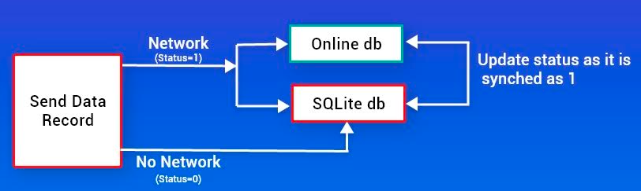

Network | Make API call and store the row in central PHS DB, also save in local SQLite DB. Set a sync_flag of record as 1 in local SQLite DB
No Network | Store the record in SQLite DB. Set a sync_flag of record as 0 in local SQLite DB and sync with the online DB when the network is back. Update sync_flag for the record as 1 as it is synched.

Master Data sync: When users launch the app, the app needs to download some records from the central PHS before the app gets functional / ready to use. They can be the following types:
- BaseSyncQuery Master Data sync API which does not use lastSync values to retrieve data.
- DeltaSyncQuery Master Data sync API which tracks the last time (lastSync values) they successfully ran a query to sync data. Delta sync is a type of synchronization where only updated records from the database are synced. The app will only sync the changed updated records instead of downloading the entire table again. The API for this will be sent with a date time parameter and as response will only get changes that occurred after that time.

Master Data can be of two types:
- Common Master Data which includes blood groups, castes, religions and so on
- Institution specific Master Data which includes Wards, Taluks, Districts configured for an app user (JPHN/JHI) allocated to a particular institute (FWC).

There can be separate APIs for
- BaseSyncQuery Master Data sync API for common master and institution specific master data
- DeltaSyncQuery Master Data sync API for common master and institution specific master data

Download Data Synchronization API
/BaseSyncQueryComMas | BaseSyncQuery Common Master Data sync API for data such as blood group, category, and so on
/BaseSyncQueryInstMas | BaseSyncQuery Institution specific Master Data sync API for data such as ward, taluk, locality and so on.
/DeltaSyncQueryComMas | DeltaSyncQuery Common Master Data sync API for data such as blood group, category, and so on
/DeltaSyncQueryInstMas | DeltaSyncQuery Institution specific Master Data sync API for data such as ward, taluk, locality and so on.

Define response JSON formats for common master data.

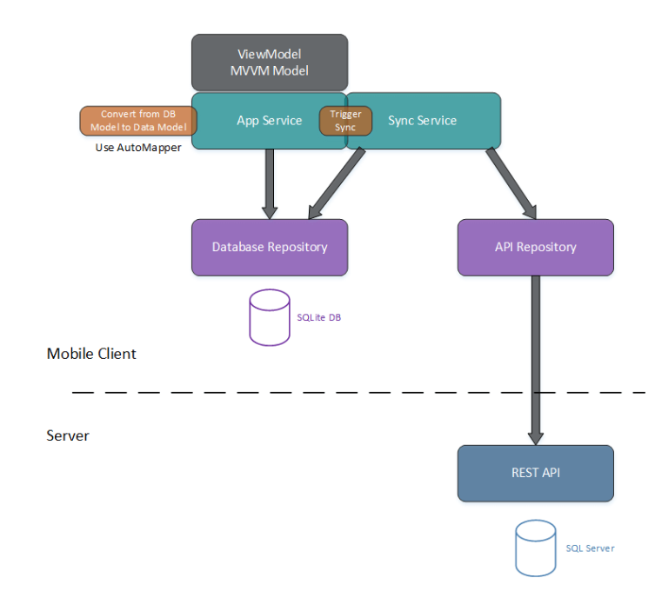

After successful login, the synchronization process should be initiated from app and should take these steps:

Read local database changes since last synchronization

Send changes to server that applies them to database

Handle any conflict may occur

Read changes from central db since last time client synchronized and send back to app

Apply changes received from server to local database

Download synchronization

Download synchronization is done for the following scenario:

Download Data Synchronization API
/downloadSyncMasData | Common Master Data sync API for data such as blood group, category, and so on. (How to track for incremental changes in master lookup data?)
/BaseSyncQueryComMas | BaseSyncQuery Common Master Data sync API for data such as blood group, category, and so on
/BaseSyncQueryInstMas | BaseSyncQuery Institution specific Master Data sync API for data such as ward, taluk, locality and so on.
/DeltaSyncQueryComMas | DeltaSyncQuery Common Master Data sync API for data such as blood group, category, and so on
/DeltaSyncQueryInstMas | DeltaSyncQuery Institution specific Master Data sync API for data such as ward, taluk, locality and so on.

Module performs the following

Upload data synchronization from app to PH server

Download data synchronization for look up data from PH server to app (full)

Download data synchronization for look up data from PH server to app (incremental updates)

Download data synchronization for user specific look up data from PH server to app (full)

Download data synchronization for user specific look up data from PH server to app (incremental updates)

Download survey data (ASHA Block specific)

        - Sub Module – Upload Data

- Inputs

- Process

- Outputs

- Database

        - Sub Module – Download look up Data (full)

- Inputs

- Process

- Outputs

- Database

        - Sub Module – Download look up Data (incremental updates)

- Inputs

- Process

- Outputs

- Database

        - Sub Module – Download user specific look up Data (full)

- Inputs

- Process

- Outputs

- Database

        - Sub Module – Download user specific look up Data (incremental updates)

- Inputs

- Process

- Outputs

- Database

        - Sub Module – Download Survey data (ASHA Block specific)

- Inputs

- Process

- Outputs

- Database

Download sync data (from central server to device app)

The API call will have the following request inputs
- PEN
- App Institution ID (Sub Centre / Basic Section ID) if the app is being used with an institution (instIDFromApp)
- ASHA Block ID if the app is being used with an ASHA Block. Multiple ASHA Block IDs to be supported in future. (AshaBlockIDsFromApp)
- User ID (through response from Authentication success)
- Institution ID (through response from Authentication success)

The app may be with the following from a successful authentication response.
- Role ID (through response from Authentication success)
- Menu Feature Permitted (through response from Authentication success)

After successful authentication, two APIs will be called from app for the following. The first two APIs can be called after successful user authentication and third API to call after an ASHA Block is selected.

- API1: /api/vr1/downloadSyncMasData Common Lookup data download sync from server to app (only incremental changes)
- API2: /api/vr1/downloadSyncUserData User-Institution (SubCentre/BasicSection) specific Lookup data download sync from server to app (only incremental changes)
- API3: /api/vr1/downloadSyncAshaBlData User-Institution-ASHA Block selected specific data download sync from server to app. (the data for the existing ASHA Block will be removed for centralized ID formation and download synched even if same ASHA Block selected.)

The procedure to check for incremental change will be:
- Get max of last_chg_date and last_chg_time from the table in device app
- Pass this as argument to server side service API
- Get only the records made/updated after the passed date
- In app side, check for ID to determine whether INSERT or UPDATE operation is needed.

API1 Process: /api/vr1/downloadSyncMasData

Only incremental changes needs to download if the app is already set for use by a valid user for an institute. The latest date on which the records of each lookup table was updated will be given as input to the service. Through this only changes after this date will needs to be download synched to app. So the input to service can be a JSON with table name as key and latest date on which the table’s records were updated.

{"down_sync_lookup_reclastupdate":

[{

"tablename": "name of table1 as a string",

"last_change_datetime": "the latest date till which updates are done"

},

{

"tablename": "name of table2 as a string",

"last_change_datetime": "the latest date till which updates are done"

}]

}

Common Lookup tables include the following:
- mas_administrative_sex
- mas_blood_group
- mas_category
- mas_continent
- mas_country
- mas_currency
- mas_department
- mas_district
- mas_hospital_type
- mas_lsg_type
- mas_marital_status
- mas_occupation
- mas_rank
- mas_religion
- mas_service_centre_counter
- mas_state
- mas_sub_chargecode
- mas_survey
- mas_survey_details

API2 Process: /api/vr1/downloadSyncUserData

Request JSON format

{

“pen”:””

“deviceIDFromApp”:””

“instIDFromApp”:””

“AshaBlockIDsFromApp”:[“”,””,””],

{"down_sync_lookup_reclastupdate":

[{

"tablename": "name of table1 as a string",

"last_change_datetime": "the latest date till which updates are done"

},

{

"tablename": "name of table2 as a string",

"last_change_datetime": "the latest date till which updates are done"

}]

}

}

Only incremental changes need to be sent from server to app. All lookup data specific to user and user’s institution will be fetched and sent to app. (InstIDFromApp may be null if no institutions currently configured in mobile app and AshaBlockIDsFromApp may be null if no ASHA Blocks currently configured in mobile app)

- Get PEN from request
- Get Employee ID (employee_id) from table mas_employee using PEN (pe_no)
- Form response JSON with row from mas_employee corresponding to PEN
- Get User ID (user_id) and Institution ID (hospital_id) from table users by using Employee ID (employee_id)
- Form response JSON with row from table users corresponding to user_id
- Form response JSON with row from table mas_hospital corresponding to user’s Institution ID (hospital_id)
- Form response JSON with rows from table location_parameter_mapping corresponding to user’s Institution ID (hospital_id)
- Get Ward IDs from table location_parameter_mapping corresponding to user’s Institution ID (hospital_id)
- Form response JSON with rows from table mas_ward corresponding to user’s Ward IDs
- Get Post Code IDs from table location_parameter_mapping corresponding to user’s Institution ID (hospital_id)
- Form response JSON with rows from table mas_post_code corresponding to user’s Post Code IDs
- Get LSG IDs from table location_parameter_mapping corresponding to user’s Institution ID (hospital_id)
- Form response JSON with rows from table mas_lsg corresponding to user’s LSG IDs
- Get Village IDs from table location_parameter_mapping corresponding to user’s Institution ID (hospital_id)
- Form response JSON with rows from table mas_village corresponding to user’s Village IDs
- Get Taluk IDs from table location_parameter_mapping corresponding to user’s Institution ID (hospital_id)
- Form response JSON with rows from table mas_taluk corresponding to user’s Taluk IDs
- Get Parliament-Assembly IDs from table location_parameter_mapping corresponding to user’s Institution ID (hospital_id)
- Form response JSON with rows from table ph_mas_parliyament_assembly corresponding to user’s Parliament-Assembly IDs
- Get Ward IDs from table location_parameter_mapping corresponding to user’s Institution ID (hospital_id)
- Form response JSON with rows from table mas_ward corresponding to user’s Ward IDs
- Get District ID from table mas_hospital for the district of the institution
- Form response JSON with rows from table ph_mas_electrical_section corresponding to user’s District IDs
- Get list of ASHA Blocks (ashablock_id) assigned to the user by using user_id and hospital_id from table ph_ashablock_assign
- Form response JSON with rows from table ph_ashablock_assign corresponding to user’s Institution ID (hospital_id) and User ID (user_id)
- Get list of ASHA Blocks for the Institution ID (hospital_id) and ASHA Blocks assigned to the user from table ph_ashablocks
- Form response JSON with rows from table ph_ashablocks corresponding to user’s Institution ID (hospital_id) and user’s assigned ASHA Blocks.

User-Institution (SubCentre/BasicSection) specific tables include the following
- mas_employee
- users
- mas_hospital
- location_parameter_mapping
- mas_ward
- mas_post_code
- mas_lsg
- mas_village
- mas_taluk
- ph_mas_parliyament_assembly
- mas_ward
- ph_mas_electrical_section
- ph_ashablocks
- ph_ashablock_assign

API3 Process: /api/vr1/downloadSyncAshaBlData

The service API will be called after selecting ASHA Blocks by the user. There can be multiple ASHA Blocks selected by the user.

Request JSON format

{

“pen”:””

“deviceIDFromApp”:””

“instIDFromApp”:””

“AshaBlockIDsFromApp”:[“”,””,””],

“AshaBlockIDsSelectUser”: [“”,””,””],

{"down_sync_lookup_reclastupdate":

[{

"tablename": "name of table1 as a string",

"last_change_datetime": "the latest date till which updates are done"

},

{

"tablename": "name of table2 as a string",

"last_change_datetime": "the latest date till which updates are done"

}]

}

}

The property AshaBlockIDsSelectUser will be an array holding ASHA Blocks selected by the user. The property AshaBlockIDsFromApp will be the ASHA Blocks previously set by the user.

- Get AshaBlockIDsSelectUser for the list of ASHA Blocks set by the user for survey
- Form response JSON with rows from table ph_ashablock_localities corresponding to fields user’s hospital_id, ward_id and ashablock_id. There can be more than one ASHA Block IDs mapped to a user.
- Get list of Locality IDs (locality_id) from ph_ashablock_localities corresponding to fields user’s hospital_id, ward_id and ashablock_id. There can be more than one ASHA Block IDs mapped to a user
- Form response JSON with rows from table ph_mas_locality for the Locality IDs in the ASHA Block (ASHA Blocks assigned to the user)
- Get list of houses mapping with selected ASHA Blocks (there can be multiple ASHA Blocks selected for a user) by using asha_block_id in ph_ashablock_housemapping
- Form response JSON with rows from table ph_ashablock_housemapping corresponding to user assigned ASHA Block IDs
- Get list of houses mapped to ASHA Blocks assigned to user.
- Form response JSON with rows from table ph_house_survey.
- Get list of members in the house.
- Form response JSON with rows from table ph_member_survey.
- Get list of families in the house.
- Form response JSON with rows from table ph_family_survey.
- Get list of relations in the families in the house
- Form response JSON with rows from table ph_member_relation.

User-Institution-ASHA Block selected specific tables include the following
- ph_ashablock_localities
- ph_mas_locality
- ph_ashablock_housemapping
- ph_house_survey
- ph_member_survey
- ph_family_survey
- ph_member_relation

The following tables not synched as of now
- ph_ashablock_ashamapping
- ph_temporary_registration

  - Module – APIs for OTP handling
    - Hardware

Not Applicable
    - Software
      - Description – Module

The module will perform the following

        - Sub Module – OTP generation
- Inputs
- Process
- Outputs
- Database

        - Sub Module – OTP verification
- Inputs
- Process
- Outputs
- Database

        - Sub Module – OTP limit check
- Inputs
- Process
- Outputs
- Database

      - User Interface
      - Communication Interface
    - Mechanical

Not Applicable

  - Module – Retrieving Institution information for user
    - Hardware

Not Applicable
    - Software
      - Description – Module

The module will perform the following

        - Sub Module
- Inputs
- Process
- Outputs
- Database

        - Sub Module
- Inputs
- Process
- Outputs
- Database

        - Sub Module
- Inputs
- Process
- Outputs
- Database

        - Sub Module
- Inputs
- Process
- Outputs
- Database

      - User Interface
      - Communication Interface
    - Mechanical

Not Applicable

Annexure – 1: Application Source files

The folder structure and files for common folder
app.dart -- Part of application entry file main.dart
app_prefs.dart -- application level configuration key-value pairs
constant.dart -- defines values for local DB file, base URLs
db_helper.dart -- defines data connection objects
di.dart -- service locator central registry of classes
extensions.dart -- to add addl functionality to flutter datatypes
functions.dart -- shared common functions for application
logger.dart -- for logging info
network_info.dart -- for checking network connection or not

The folder structure and files for presentation folder
├───common
│ ├───baseviewmodel
│ │ baseviewmodel.dart --base viewmodel class
│ │
│ └───state_renderer
│ state_renderer.dart --common classes for error/info popups
│ state_render_impl.dart
│
├───flutter_flow --theme and style files from flutterflow
│ │ flutter_flow_animations.dart
│ │ flutter_flow_drop_down.dart
│ │ flutter_flow_icon_button.dart
│ │ flutter_flow_radio_button.dart
│ │ flutter_flow_theme.dart
│ │ flutter_flow_util.dart
│ │ flutter_flow_widgets.dart
│ │ internationalization.dart
│ │ lat_lng.dart
│ │ place.dart
│ │
│ └───nav
│ serialization_util.dart
│
├───forgot_password
│ │ forgot_password_view.dart -- file for UI
│ │ forgot_password_viewmodel.dart -- view model file for UI
│ │
│ └───dataobjects
│ freezed_data_classes.dart -- for data handling in viewmodel
│ freezed_data_classes.freezed.dart -–autogenerated code
│
├───homepage
│ │ homepage.dart -- file for UI
│ │ homepage_viewmodel.dart -- view model file for UI
│ │
│ ├───dashboard –- presentation layer files for dashboard
│ ├───dataobjects
│ │ freezed_data_classes.dart -- for data handling in viewmodel
│ │ freezed_data_classes.freezed.dart -–autogenerated code
│ │
│ └───mainmenu
├───housesearch
├───housesurvey
│ │ house_survey.dart -- file for UI
│ │ house_survey_viewmodel.dart -- view model file for UI
│ │
│ └───dataobjects
│ freezed_data_classes.dart -- for data handling in viewmodel
│ freezed_data_classes.freezed.dart -–autogenerated code
│
├───login
│ │ eh_mpin_view.dart -- file for UI
│ │ eh_pen_view.dart -- file for UI
│ │ eh_pen_viewmodel.dart -- view model file for UI
│ │ forgot_password_view.dart -- file for UI
│ │ forgot_password_viewmodel.dart -- view model file for UI
│ │ login_view.dart -- file for UI
│ │ login_viewmodel.dart -- view model file for UI
│ │
│ └───dataobjects
│ freezed_data_classes.dart -- for data handling in viewmodel
│ freezed_data_classes.freezed.dart -–autogenerated code
│
├───membersearch --presentation files for member search feature
├───membersurvey --presentation files for member survey feature
│ └───dataobjects
│ freezed_data_classes.dart
│ freezed_data_classes.freezed.dart
│
├───ncd --presentation files for NCD feature
│ └───dataobjects
│ freezed_data_classes.dart
│ freezed_data_classes.freezed.dart
│
├───resources --files for resource management
│ assets_manager.dart –defines image files
│ color_manager.dart --defines color used in UI
│ font_manager.dart --defines style fonts used in UI
│ language_manager.dart --defines languages supported
│ routes_manager.dart –- defines menu navigation routes
│ strings_manager.dart –-defines labels for UI
│ styles_manager.dart –-defines text styles
│ theme_manager.dart –-defines themes
│ values_manager.dart –-defines values for margins, padding
│
└───splash
splash.dart –- dart file for splash screen

The folder structure and files for domain folder
├───common
│ └───baseusecase
│ base_usecase.dart –- base usecase class
│
├───homepage
│ ├───model
│ │ model.dart –- model class
│ │
│ ├───repository
│ │ repository.dart –- data repository interface class
│ │
│ └───usecase
│ homepage_usecase.dart –- use case class for each activity
│
├───housesearch
├───housesurvey
│ ├───model
│ │ model.dart –- model class
│ │
│ ├───repository
│ │ repository.dart –- data repository interface class
│ │
│ └───usecase
│ housesurvey_usecase.dart –- use case class for each activity
│
├───login
│ ├───model
│ │ model.dart –- model class
│ │
│ ├───repository
│ │ repository.dart –- data repository interface class
│ │
│ └───usecase
│ eh_pen_usecase.dart –- use case class for each activity
│ forgot_password_usecase.dart
│ login_usecase.dart
│
├───membersearch
├───membersurvey
└───ncd

The folder structure and files for data folder
│
├───common
│ └───base
│ dio_factory.dart –- defines request header for remote API calls
│ error_handler.dart –-error handlers for all service calls
│ failure.dart –- failure object with code for all service calls
│
├───homepage
├───housesearch
├───housesurvey
│ ├───data_source
│ │ db_data_soure.dart –- data source object for SQLite DB
│ │ remote_data_source.dart –- data source object for remote API
│ │
│ ├───localdb
│ │ localdb_api.dart -– SQLite client interface for DB API
│ │
│ ├───mapper
│ │ mapper.dart --null safety for responses from APIs
│ │
│ ├───network
│ │ app_api.dart –- Web client interface for remote service API
│ │ app_api.g.dart –- auto-generated code thru retrofit http client
│ │
│ ├───repository
│ │ repository_impl.dart –- data repository interface class
│ │
│ ├───request
│ │ request.dart –- request classes for service calls
│ │
│ └───responses
│ responses.dart –- response classes for service calls
│ responses.g.dart -– auto-generated code with JSON representation
│
├───login
│ ├───data_source
│ │ db_data_soure.dart –- data source object for SQLite DB
│ │ remote_data_source.dart –- data source object for remote API
│ │
│ ├───localdb
│ │ localdb_api.dart -– SQLite client interface for DB API
│ │
│ ├───mapper
│ │ mapper.dart --null safety for responses from APIs
│ │
│ ├───network
│ │ app_api.dart –- Web client interface for remote service API
│ │ app_api.g.dart –- auto-generated code thru retrofit http client
│ │
│ ├───repository
│ │ repository_impl.dart –-data repository implementation class
│ │
│ ├───request
│ │ request.dart –- request classes for service calls
│ │
│ └───responses
│ responses.dart –- response classes for service calls
│ responses.g.dart-–auto-generated code with JSON formats
│
├───membersearch
├───membersurvey
└───ncd

Annexure – 2: Class Diagrams

House Survey | housesurvey_classdiagram.svg

Annexure – 2: Web API Backend development environment setup

Annexure – 3: Database Design – Offline mobile DB in SQLite

  - ph_house_survey

 | Name | Type | Constraints | Description
 | survey_id | SERIAL  INTEGER | Primary Key | Primary Key
 | house_hold_id | INTEGER | NOT NULL | The ID will be generated on server side and will be updated at app side only through a download data sync. The survey_id will be the reference for house data in app if this field is NULL.  This is a 9 digit application defined ID for House Survey.  The format is <5 digit Institution Code><4 digit Incremental part>. 5 digit Institution Code refers to the hospital_code in mas_hospital.  This will be NULL when a new house data is created in app.
 | inmate_id | INTEGER | NOT NULL | Whether the building being surveyed represents a house, orphanage, jail based on type of inmates (Indicates the type of accommodation premise such as house, hostel, orphanage, jail)
 | sub_center_id | INTEGER | NOT NULL | Location parameter from sub centre id for JPHN or basic section id for JHI. The IDs mapped to be retrieved from sub_center_id field of location_parameter_mapping for FWC of logged in user.
 | basic_section_id | INTEGER | NOT NULL | Location parameter from sub centre id for JPHN or basic section id for JHI. The IDs mapped to be retrieved from basic_section_id field of location_parameter_mapping for FWC of logged in user. Name reference from mas_hospital
 | taluk_id | INTEGER | NOT NULL | Derived location parameter from sub centre id for JPHN or basic section id for JHI. Taluk ID for the village. Name reference from mas_taluk
 | village_id | INTEGER | NOT NULL | Derived location parameter from sub centre id for JPHN or basic section id for JHI. Name reference from mas_village.
 | parliyament_id | INTEGER | NOT NULL | Derived location parameter from sub centre id for JPHN and basic section id for JHI. The IDs mapped to be retrieved from parliyament_id field of location_parameter_mapping for FWC of logged in user. Name reference from ph_mas_parliyament_assembly based on field category value as P
 | assembly_id | INTEGER | NOT NULL | Derived location parameter from sub centre id for JPHN and basic section id for JHI. The IDs mapped to be retrieved from assembly_id field of location_parameter_mapping for FWC of logged in user. Name reference from ph_mas_parliyament_assembly based on field category value as A
 | panchayat_id | INTEGER | NOT NULL | Derived location parameter LSGI from sub centre id for JPHN and basic section id for JHI. The IDs mapped to be retrieved from lsg_id field of location_parameter_mapping for FWC of logged in user. Name reference from mas_lsg.
 | ward_id | INTEGER | NOT NULL | Derived location parameter Ward from sub centre id for JPHN and basic section id for JHI. The IDs mapped to be retrieved from ward_id field of location_parameter_mapping for FWC of logged in user. Name reference from mas_ward.
 | asha_block_id | INTEGER | NOT NULL | ASHA Block ID to which the house belongs to. Name reference from ?
 | locality_id | INTEGER | NOT NULL | Locality of the house. The IDs mapped to be retrieved from locality_id field of location_parameter_mapping for FWC of logged in user. Name reference from mas_locality.
 | pin_code_id | INTEGER |  | ID for post office. The IDs mapped to be retrieved from post_code_id field of location_parameter_mapping for FWC of logged in user. Name reference from mas_post_code.
 | latitude | TEXT | NOT NULL | Latitude
 | longitude | TEXT | NOT NULL | Longitude
 | lsg_status | TEXT | CHECK (‘Y’,’N’) | Field to store whether LSG number for the house is available or not. If the LSG number for the house is not known, value will be N. Otherwise Y.
 | lsg_house_no | TEXT | Default NULL | If NULL, LSG house number not available for the house. Otherwise the field holds LSG house number for the field.
 | address | TEXT | NOT NULL | House Name
 | street_name | TEXT |  | Street Name
 | occupancy_status_id | INTEGER | NOT NULL | ID reference from mas_survey with survey_id = 75;
 | member_count | INTEGER | NOT NULL | Number of members in accommodation premise
 | contact_no | TEXT |  | To keep landline number
 | locality_type_id | TEXT | NOT NULL | ID reference from mas_survey with survey_id = 65; Multiple values are allowed and values are separated by a comma character.
 | electrification_status | TEXT | Y or N | Electrified or not
 | drinking_water_source_id | TEXT |  | ID reference from mas_survey with survey_id = 68. Multiple values are allowed and values are separated by a comma character.
 | domestic_water_safety | TEXT | Y or N | Domestic water safely kept?
 | latrine_id | TEXT |  | ID reference from mas_survey with survey_id = 71. Multiple values are allowed and values are separated by a comma character.
 | solid_waste_disposal_method_id | TEXT |  | ID reference from mas_survey with survey_id =72. Multiple values are allowed and values are separated by a comma character.
 | lwd_sewage_id | INTEGER |  | ID reference from mas_survey with survey_id = 73
 | lwd_sullage_id | INTEGER |  | ID reference from mas_survey with survey_id = 73
 | cooking_fuel_id | TEXT |  | ID reference from mas_survey with survey_id = 76. Multiple values are allowed and values are separated by a comma character.
 | well_type_status | TEXT | Y or N | Has well or not?
 | animal_pet | TEXT | Y or N | Has animals or pets?
 | pets_info_id | TEXT |  | ID reference from mas_survey with survey_id = 74; Multiple values are allowed and values are separated by a comma character.
 | remarks | TEXT | A limit of 250 characters | Remarks
 | hospital_id | INTEGER | ?? | Subcentre id for JPHN and Basic Section ID for JHI? (institution ID from where the record was created)
 | house_survey_by | INTEGER | ?? | The ID of the user who first surveyed the house (the user who created the record)
 | house_survey_date | TEXT |  | The date on which house was surveyed (the record created date)
 | house_survey_time | TEXT |  | The time at which house was surveyed (the record created date)
 | last_chg_id | INTEGER | ?? | The subcentre/basic section or asha block id from where house survey data updated last time
 | last_chg_by | INTEGER | ?? | The ID of the user who updated house survey data for last time
 | last_chg_date | TEXT |  | The date on which house survey record was changed for last
 | last_chg_time | TEXT |  | The date on which house survey record was changed for last
 | house_survey_status | TEXT | Y or N. Default is Y | Active or Inactive? Event for which house is inactive?
 | sync_flag | TEXT | Y or N | Whether the current data with the record synched to server. Immediately after a modification to the record data, the field is set to N. After successful sync, the value will be set to Y.

  - ph_member_survey

 | Name | Type | TYPE (SQLite) | Constraints | Description
 | survey_id | SERIAL  INTEGER |  | Primary Key | Primary Key
 | member_id | BIGINT |  | NOT NULL | The ID will be generated on server side and will be updated at app side only through a download data sync. The survey_id will be the reference for member data in app if this field is NULL.  This is a 12 digit application defined ID for each member.  House ID (9digits) + Increment (3 digits). House ID is the house_hold_id in ph_house_survey table. Ex: 2031923001where 2031923 is the house_hold_id. This will be NULL when a new member is added through the app.
 | house_id | INTEGER |  | FK  ph_house_survey(house_hold_id) | This is a 9 digit application defined ID for House Survey.  This refers to house_hold_id in ph_house_survey.  The field will be NULL if the member data are being inserted before the house_id is generated by the sever. In those cases a temp_house_id will hold the reference to house data till the member data is synched to server. If this field value is there this will be used to reference house. Otherwise temp_house_id is used.
 | temp_house_id | INTEGER |  | FK ph_house_survey(survey_id) | The field house_id will be NULL if the member data are being inserted before the house_id is generated by the sever. In those cases a temp_house_id will hold the reference to house data till the member data is synched to server and house_id is generated. If house_id field value is there that will be used to reference house. Otherwise temp_house_id is used.
 | family_id | BIGINT |  | FK ph_family_survey(family_id) | ID of the family to which the member belongs to. varchar(32) type in referencing table (need to do cast for various data querying). The field will be NULL if the family data are being added before the family_id is generated by the sever. In those cases a temp_family_id will hold the reference to family data till the family data is synched to server. If this field value is there this will be used to reference house. Otherwise temp_family_id is used.
 | temp_family_id | BIGINT |  | FK ph_family_survey(survey_id) | The field family_id will be NULL if the family data are being added before the family_id is generated by the sever. In those cases a temp_family_id will hold the reference to family data till the family data is synched to server and family_id is generated. If family_id field value is there that will be used to reference family. Otherwise temp_family_id is used.
 | uhid_no | VARCHAR(25) |  |  | Unique Health Identification (UHID) Number. The number not generated from PH system but through eHealth Clinical system and will be updated in PH server. The field in device app initially will be NULL and populated after the first data synchronization.
 | entry_flag | VARCHAR(32) |  | CHECK(Y,N) | The value will be Y when data captured through Aadhaar QR scan mode and N when data captured through manual (not QR mode). And NULL when Aadhaar data not captured.
 | aadhaar_no | BIGINT |  |  | Aadhaar Number. Captured through QR code scanning
 | qr_type | VARCHAR(32) |  |  | Type of QR scan done for Aadhaar scanning. A value retrieved from Aadhaar scan response JSON? The field will have value only when data captured through Aadhaar QR code scanning. Otherwise, NULL. The field qr_type handles 4 types of Aadhaar QR scan.
 | aadhaar_district | INTEGER |  | FK  mas_district(district_id) | District information as per Aadhaar QR scan. A value retrieved from Aadhaar scan response JSON and it will be a text value. The field will have value only when data captured through Aadhaar QR code scanning. Otherwise, NULL. Text based string matching done between Aaadhaar XML response and district names in mas_district to identify look up IDs from mas_district.
 | aadhaar_state | INTEGER |  | FK  mas_state(state_id) | State information as per Aadhaar QR scan. A value retrieved from Aadhaar scan response JSON and it will be a text value. The field will have value only when data captured through Aadhaar QR code scanning. Otherwise, NULL. Text based string matching done between Aaadhaar XML response and state names in mas_state to identify look up IDs from mas_state
 | aadhaar_address | VARCHAR(128) |  |  | A value retrieved from Aadhaar scan response JSON/XML. The field will have value only when data captured through Aadhaar QR code scanning. Otherwise, NULL. Currently only Pincode data from Aadhaar XML parsing is retrieved and stored here.
 | id_card_type | INTEGER |  |  | Type of an identity card entered other that Aadhaar. The valid options are Driving License, PAN Card, Passport and Voters ID. The corresponding values are stored in the field id_card_value. ID reference from mas_survey with survey_id = 40
 | id_card_value | VARCHAR(24) |  | NOT NULL; A text limit of 24 characters | The value for the selected ID card other than Aadhaar
 | aabha_id | VARCHAR(24) |  |  | Ayushman Bharat Health Account (ABHA) number is a 14 digit number that will uniquely identify you as a participant in India's digital healthcare ecosystem. Previously known as Health ID
 | aabha_no | VARCHAR(24) |  |  | ABHA number
 | aabha_address | VARCHAR(256) |  |  | ABHA Address
 | name | VARCHAR(64) |  | A text limit of 64 characters | Member Name
 | date_of_birth | TEXT |  |  | Date of Birth
 | year_of_birth | INTEGER |  |  | Year of Birth
 | notional_dob | TEXT |  |  | The Date of Birth in format 1/1/<year of birth>. Formed when age is entered through Age (Years, Months, Days) fields
 | gender | INTEGER |  | FK  mas_administrative_sex (administrative_sex_id) | ID for Gender
 | relationship_name | INTEGER |  |  | ID reference from mas_survey with survey_id = 88. The Survey question.docx with fields as Father, Mother, Guardian, Husband.  The field will have value only when data captured through manual (not QR scan) mode. Otherwise NULL
 | person_name | VARCHAR(64) |  | A text limit of 64 characters | Person name response w.r.t relationship (stored in field relationship_name)  When data captured through QR scan of Aadhaar, the format is <S/O: or D/O: or W/O: C/O:><Person Name>. ie. Both relationship and person name kept through this field.  When data captured through manual (not QR scan) mode, the field will store person name and corresponding relation in relationship_name field
 | house_name | VARCHAR(128) |  | A text limit of 128 characters | When data captured through QR scan of Aadhaar, the field stores House Name as in Aadhaar. When data captured through manual mode, the same field is updated with user entered house name
 | street_name | VARCHAR(128) |  | A text limit of 128 characters | When data captured through QR scan of Aadhaar, the field stores Street Name as in Aadhaar. When data captured through manual mode, the same field is updated with user entered street name
 | contact_no | VARCHAR(32) |  |  | The mobile number
 | individual_category | INTEGER |  |  | ID reference from mas_survey with survey_id = 59.
 | marital_status | INTEGER |  | FK  mas_marital_status(marital_status_id) | Marital Status  The values in mas_marital_status and Survey question.docx does not match. The option values will be from PHS server database
 | religion | INTEGER |  | FK  mas_religion(religion_id) | Religion of the member
 | social_category | INTEGER |  | FK  mas_category(category_id) | Social category of the member
 | nativity_id | INTEGER |  |  | ID reference from mas_survey with survey_id = 83
 | residential_status_id | INTEGER |  |  | ID reference from mas_survey with survey_id = 84. The field will have value only when nativity_id is Native. For Migrant and Foreigner, the field value will be NULL.
 | exp_period_stay | VARCHAR(10) |  | A text limit of 10 characters | The field will have value only when nativity_id is Migrant or Foreigner, otherwise NULL. Expected period of stay in months.
 | source_state | INTEGER |  | FK  mas_state(state_id) | The field will have value only when nativity_id is Migrant, otherwise NULL. The state from where they arrived.
 | source_district | INTEGER |  | FK  mas_district(district_id) | The field will have value only when nativity_id is Migrant, otherwise NULL. The distrit from where they arrived.
 | cont_no_contractor | VARCHAR(32) |  | A text limit of 32 characters | The field will have value only when nativity_id is Migrant, otherwise NULL. The field stores contact number of contractors.
 | source_country | INTEGER |  | FK  mas_country(country_id) | The field will have value only when nativity_id is Foreigner, otherwise NULL. The field stores country from where the person arrived.
 | passport_no | VARCHAR(16) |  | A text limit of 16 characters | The field will have value only when nativity_id is Foreigner, otherwise NULL. The field stores the passport number for a foreigner.
 | occupation | INTEGER |  | FK  mas_occupation(occupation_id) | The occupation for member
 | education | INTEGER |  |  | ID reference from mas_survey with survey_id = 87.
 | insurance_status | VARCHAR(32) |  | CHECK(Y,N) | Whether member has health insurance or not.
 | health_insurance_type | VARCHAR(256) |  |  | Holds the type of health insurance hold by member. Will have value only when insurance_status is Yes. Otherwise NULL. ID reference from mas_survey with survey_id = 81. Multiple IDs can be kept and those will be separated by a comma (,) character.
 | blood_group_id | INTEGER |  | FK  mas_blood_group(blood_group_id) | Blood Group
 | major_health_issue_status | CHAR(1) |  | CHECK(Y,N) | Field to store major health issue status
 | major_health_issue_id | VARCHAR(16) |  | VARCHAR(16) | ID reference from mas_survey with survey_id = 79. Multiple IDs can be kept and those will be separated by a comma (,) character
 | immunization_status | INTEGER |  |  | ID reference from mas_survey with survey_id = 82. The field will have value only for members whose age below 20 at the time of data capture.
 | type_of_disability_status | CHAR(1) |  | CHECK(Y,N) | Field to store disability status
 | type_of_disability_id | VARCHAR(16) |  |  | ID reference from mas_survey with survey_id = 80. Multiple IDs can be kept and those will be separated by a comma (,) character.  The field will have value only when there is a disability added for the member. Otherwise NULL.
 | disability_percentage | VARCHAR(8) |  | A text limit of 8 characters | The field will have value only when there is a disability added for the member. Otherwise NULL.
 | udid_no | VARCHAR(16) |  |  | The field will have value only when there is a disability added for the member. Otherwise NULL. The field stores Unique Disability ID (UDID)
 | smoking_status | VARCHAR(4) |  | CHECK (Y, N) | The field stores response to whether member smoker/ex-smoker
 | smoking_age | INTEGER |  |  | The field will have value only when smoking_status is Yes. Otherwise NULL. The field stores at what age member started smoking
 | smoking_details | INTEGER |  |  | The field will have value only when smoking_status is Yes. Otherwise NULL. The field stores the frequency of smoking.  ID reference from mas_survey with survey_id = 46.
 | tobacco_status | VARCHAR(4) |  | CHECK(Y,N) | The field stores response to whether member use tobacco
 | tobacco_details | INTEGER |  |  | The field will have value only when tobacco_status is Yes. Otherwise NULL. The field stores the frequency of tobacco usage.  ID reference from mas_survey with survey_id = 41.
 | alcohol_status | VARCHAR(4) |  | CHECK(Y,N) | The field stores response to whether member use alcohol
 | alcohol_details | INTEGER |  |  | The field will have value only when alcohol_status is Yes. Otherwise NULL. The field stores the frequency of alcohol usage.  ID reference from mas_survey with survey_id = 90.
 | death_status | VARCHAR(32) |  | CHECK (Y, N) | Initially value N, updated through Death Registration
 | date_of_death | TEXT |  |  | Initially NULL, updated through Death Registration
 | transfer_status |  |  | CHECK (Y, N) | Initially value NULL, updated through Member Transfer module
 | remarks | TEXT |  | A limit of 512 characters | Remarks
 | hof_status | TEXT | VARCHAR(32) |  | The field to keep Head of Family status of a member. Y if the member is Head of Family and NULL, if not Head of Family. This data field initially will be NULL when a member is added. And will have value only when member is marked as Head of Family through Relationship module.
 | bpl_type | TEXT | CHAR(1) |  | BPL Ration Card Yes/No?
 | bpl_type_category | INT | INTEGER |  | ID reference from mas_survey with survey_id = ?
 | ration_card_no | TEXT | VARCHAR(32) |  | The ration card number for the member. This data field initially will be NULL when a member is added. And will have value only when member made part of a ration card through Ration Card Grouping module
 | hospital_id | INTEGER |  |  | Subcentre id for JPHN and Basic Section ID for JHI? (institution ID from where the record was created)
 | member_survey_by | INTEGER |  |  | The ID of the user who first surveyed the house (the user who created the record)
 | member_survey_date | TEXT |  |  | The date on which member was surveyed (the record created date)
 | member_survey_time | TEXT |  |  | The time at which member was surveyed (the record created time)
 | last_chg_id | INTEGER |  |  | The subcentre/basic section from where member survey data updated last time
 | last_chg_by | INTEGER |  |  | The ID of the user who updated member survey data for last time
 | last_chg_date | TEXT |  |  | The date on which house survey record was changed for last
 | last_chg_time | TEXT |  |  | The time of the date at which member survey record was changed for last
 | is_active | CHAR(1) |  | CHECK (Y, N) | Initially Y, and set to N, when member deleted
 | sync_flag | TEXT |  | Y or N | Whether the current data with the record synched to server. Immediately after a modification to the record data, the field is set to N. After successful sync, the value will be set to Y.

  - ph_family_survey

The table stores details on families created for houses. A family will have a name. An ID will be generated for each family. The details on the members in the family are mapped through family_id field in ph_member_survey.

 | Name | Type | Type (SQLite) | Constraints | Description
 | survey_id | SERIAL  INTEGER | SERIAL  INTEGER | Primary Key | Primary Key
 | family_id | VARCHAR(32) | INTEGER |  | The field used to uniquely identify the family?  Data format followed for the creation this ID is <house_id>+<1 digit serial part>.
 | family_name | VARCHAR(256) | TEXT | NOT NULL | Name of family; A house can have more than one family
 | house_id | VARCHAR(16) | INTEGER | FK  ph_house_survey(house_hold_id) | The ID of the house to which the family belongs to. This is a 9 digit application defined ID for House each house.  This refers to house_hold_id in ph_house_survey.  The field will be NULL if the family data are being inserted before the house_id is generated by the sever. In those cases a temp_house_id will hold the reference to house data till the family data is synched to server. If this field value is there this will be used to reference house. Otherwise temp_house_id is used.
 | temp_house_id | VARCHAR(16) | TEXT | FK  ph_house_survey(survey_id) | The field house_id will be NULL if the family data are being inserted before the house_id is generated by the sever. In those cases a temp_house_id will hold the reference to house data till the family data is synched to server and house_id is generated. If house_id field value is there that will be used to reference house. Otherwise temp_house_id is used.
 | hospital_id | INTEGER | INTEGER |  | Subcentre id for JPHN and Basic Section ID for JHI? (institution ID from where the record was created)
 | survey_by | INTEGER | INTEGER |  | The ID of the user who first surveyed (the user who created the record)
 | survey_date | DATE | TEXT |  | The date on which survey was done (the record created date)
 | survey_time | TIME | TEXT |  | The time at which the record was created
 | last_chg_id | VARCHAR(8) | INTEGER |  | The subcentre / basic section from where survey data updated last time
 | last_chg_by | INTEGER | INTEGER |  | The ID of the user who updated survey data for last time
 | last_chg_date | DATE | TEXT |  | The date on which survey record was changed for last
 | last_chg_time | TIME | TEXT |  | The time at which survey record was changed for last
 | is_active | CHAR(1) | TEXT | CHECK (Y, N) | Initially Y, and set to N, when member deleted
 | sync_flag | TEXT | TEXT | Y or N | Whether the current data with the record synched to server. Immediately after a modification to the record data, the field is set to N. After successful sync, the value will be set to Y.

  - ph_member_relation

The table stores details on the relationship between members in a family.

 | Name | Type | Constraints | Description
 | relationship_id | INTEGER | Primary Key | Primary Key Primary Key(Auto Increment)
 | family_id | BIGINT | FK ph_family_survey(family_id) | The family ID of the family for which relationship is defined  ID of the family to which the members belongs to. varchar(32) type in referencing table (need to do cast for various data querying). The field will be NULL if the family data are being added before the family_id is generated by the server. In those cases a temp_family_id will hold the reference to family data till the family data is synched to server. If this field value is there this will be used to reference the family. Otherwise temp_family_id is used.
 | temp_family_id | BIGINT | FK ph_family_survey(survey_id) | The field family_id will be NULL if the family data are being added before the family_id is generated by the server. In those cases a temp_family_id will hold the reference to family data till the family data is synched to server and family_id is generated. If family_id field value is there that will be used to reference family. Otherwise temp_family_id is used.
 | member1_id | BIGINT | FK ph_member_survey(member_id) | The member ID of the member in the relation.  The field will be NULL if the member1 data are being added before the member1_id is generated by the server. In those cases a temp_member1_id will hold the reference to member1 data till the member data is synched to server. If this field value is there this will be used to reference the member1 of the relation. Otherwise temp_member1_id is used.
 | temp_member1_id | BIGINT | FK ph_member_survey(survey_id) | The field member1_id will be NULL if the relation data are being added before the member1_id is generated by the sever. In those cases a temp_member1_id will hold the reference to member1 data till the relation data is synched to server and member1_id is generated. If member1_id field value is there that will be used to reference relation data. Otherwise temp_member1_id is used.
 | member2_id | BIGINT | FK ph_member_survey(member_id) | The member ID of the member in the relation.  The field will be NULL if the member2 data are being added before the member2_id is generated by the server. In those cases a temp_member2_id will hold the reference to member2 data till the member data is synched to server. If this field value is there this will be used to reference the member2 of the relation. Otherwise temp_member2_id is used.
 | temp_member2_id | BIGINT | FK ph_member_survey(survey_id) | The field member2_id will be NULL if the relation data are being added before the member2_id is generated by the sever. In those cases a temp_member2_id will hold the reference to member2 data till the relation data is synched to server and member2_id is generated. If member2_id field value is there that will be used to reference relation data. Otherwise temp_member2_id is used.
 | relation_id | Integer |  | ID reference from mas_survey with survey_id =? for relationship look up list
 | ecr_status | character varying(4) |  | Eligible Couple Status- Y or N. Not required to update this field while removing relation
 | hospital_id | INTEGER |  | Subcentre id for JPHN and Basic Section ID for JHI? (institution ID from where the record was created)
 | survey_by | INTEGER |  | The ID of the user who first surveyed the house (the user who created the record)
 | survey_date | TEXT |  | The date on which member was surveyed (the record created date)
 | last_chg_id |  |  | The subcentre/basic section from where relation data updated last time
 | last_chg_by |  |  | The ID of the user who updated relation data data for last time
 | last_chg_time | TEXT |  | The time of the date at which relation record was changed for last
 | is_active | character varying(1) |  | Y or N. Check whether relationship valid or not
 | sync_flag | TEXT | Y or N | Whether the current data with the record synched to server. Immediately after a modification to the record data, the field is set to N. After successful sync, the value will be set to Y.

  - ph_menus

 | Name | Type | Constraints | Description
 | menu_id | INTEGER | Primary Key | Primary Key Primary Key(Auto Increment)
 | menu_name | BIGINT
 | src_form_id | BIGINT |  | The source form/module from where the menu list is to be invoked
 | parent_menu_id | Integer |  | Parent menu ID for sub menu rendering
 | order_no | Character varying(4) |  | The order of menus
 | status | Character varying(1) | CHECK (Y,N) | Whether menu active or not
 | created_by | INTEGER
 | created_datetime | TEXT

Sample Data
menu_name | src_form_id | parent_menu_id | order_no
Survey | homepage | NULL
NCD | homepage

New Survey
 | housesearch

  - ph_roles

 | Name | Type | Constraints | Description
 | role_id | INTEGER | Primary Key | Primary Key Primary Key(Auto Increment)
 | role_name | BIGINT |  | Role Name
 | status | character varying(1) | CHECK (Y,N) | Whether role active or not
 | created_by | INTEGER
 | created_datetime | TEXT

  - ph_menu_role

 | Name | Type | Constraints | Description
 | menu_role_id | INTEGER | Primary Key | Primary Key Primary Key(Auto Increment)
 | menu_id | INTEGER |  | Menu ID
 | role_id | INTEGER | Foreign Key | Role ID
 | status | Character varying(1) | CHECK (Y,N) | Whether role active or not
 | created_by | INTEGER
 | created_datetime | TEXT

  - ph_app_vers

The table holds information on the version of the app installed currently in the device. This will be checked to see whether the application is already setup with look up and data for an ASHA block.

After a successful app install or upgrade, the table needs to be populated with package information such as version, installation date. The fields app_setup and app_login will be NULL initially and those fields will be set with values only when app is setup with data and user allowed a successful login into the app. The table values will be modified only when a new app version is installed in phone. (Need to explore how to do app update with SQLite DB?)

 | Name | Type | Constraints | Description
 | app_ver_id | INTEGER | PK | Primary Key
 | app_ver | TEXT | NOT NULL | The version number currently installed in the app
 | install_date | TEXT | NOT NULL | The date on which the app installed
 | app_setup | TEXT | NOT NULL; Default N | The field will have value N after an app fresh install and also after an application update; After successfully importing (download synching) general and institution specific lookup data for the logged in user, the value of the field will be changed to Y to indicate the app is configured to use for the logged in user’s institution such as Sub Centre for JPHN and Basic Section for JHI. When value is Y, only incremental changes in lookup data needs to be imported to app while download synching. However, all lookup specific to ASHA Block and data specific to particular ASHA block selected by the user needs to be download synched irrespective the value of this field.
 | app_login | TEXT | NOT NULL; Default N | This field to store whether the user logged into the app after an install/upgrade. Immediately after an app install/upgrade, the value will be N. The value is Y after the first successful login after an install or upgrade. The field value will be tracked to determine the offline access eligibility of the user. Ex. The app user was online authenticated in a day but the app was upgraded at a later time on the same day. Then offline access will be allowed only after a 2 factor authentication.
 | is_valid | TEXT | Default Y | Whether the record represents current install version. Set to Y for currently installed version. The record value set to N when the app is upgraded with a new version and a new row inserted into this table

  - ph_login_log

 | Name | Type | Constraints | Description
 | login_log_id | INTEGER | PK | Primary Key
 | user_id | INTEGER | FK
 | user_name | TEXT | NOT NULL | The user for whom the login log information being recorded
 | login_type | TEXT | CHECK(ONLINE, OFFLINE) | The type of login
 | login_date | TEXT | CURRENT DATE | The date of login
 | login_time | TEXT | CURRENT TIME | The time of login
 | inst_tranf_status | TEXT | CHECK(Y,N) | The field will be NULL for OFFLINE login type. For ONLINE login, this will store institution transfer status response from PHS server API
 | dev_change_status | TEXT | CHECK(Y,N) | The field will be NULL for OFFLINE login type. For ONLINE login, this will store device change status response from PHS server API
 | pass_expiry_status | TEXT | CHECK(Y,N) | The field will be NULL for OFFLINE login type. For ONLINE login, this will store password expiry status response from PHS server API
 | logout_date | TEXT |  | The logout date
 | logout_time | TEXT |  | The logout time
 | is_valid | TEXT | Default Y | Whether the record valid

  - ph_user_mpin

The table stores MPIN set for the user in an encrypted format to allow offline access. There will be provisions to set and update the MPIN. The MPIN change/Forgot MPIN will require a 2 factor online authentication. The table will have only one record and the same record will be updated in case of an MPIN change. (MPIN changes to be tracked?)

 | Name | Type | Constraints | Description
 | login_log_id | INTEGER | PK | Primary Key
 | user_id | INTEGER | FK
 | user_name | TEXT | NOT NULL | The user for whom the login log information being recorded
 | mpin | TEXT |  | MPIN in encrypted format
 | mpin_set_date | TEXT | CURRENT DATE | The date of login
 | mpin_set_time | TEXT | CURRENT TIME | The time of login
 | is_valid | TEXT | Default Y | Whether the record valid

  - ph_user

 | Name | Type | Constraints | Description
 | user_id | INTEGER | PK | User ID from PHS server
 | user_name | TEXT | NOT NULL | The user for whom the login log information being recorded; PEN. Corresponds to login_name field in server
 | employee_id | INTEGER |  | The employee ID from server
 | employee_name | TEXT |  | Name of employee
 | password | TEXT |  | Password (encrypted). Server in encrypted. Logic for decrypt to implement
 | hospital_id | INTEGER |  | The ID for Sub Centre / Basic Section
 | rank_id | INTEGER |  | Rank / Designation/Role ID
 | rank_name |  |  | Rank / Designation/Role Name
 | is_valid | TEXT | Default Y | Whether the record valid

  - ph_ashablocks

The table holds information on ASHA Blocks and their mappings to wards.
 | Name | Type | Constraints | Description
 | ashablock_id | INTEGER | PK | Primary Key
 | ashablock_name | TEXT | NOT NULL | Name of ASHA Block
 | ward_id | INTEGER | NOT NULL | The Ward to which the ASHA Block belongs to
 | no_of_houses | INTEGER | NOT NULL; Default N | Number of houses mapped to the ASHA Block
 | no_of_members | INTEGER |  | Number of members mapped to the ASHA Block
 | created_by | INTEGER |  | User ID who created the record
 | created_at | TIMESTAMP |  | Date and Time of creation
 | updated_at | TIMESTAMP |  | Date and Time of updation
 | is_assigned | TEXT | Character limit 1

  - ph_ashablock_housemapping

The table holds information on ASHA Block and house mappings.
 | Name | Type | Constraints | Description
 | mapping_id | BIGINT | PK | Primary Key
 | asha_block_id | INTEGER | NOT NULL | ID reference to ASHA Block
 | house_id | BIGINT | FK ph_house_survey(house_hold_id) | The house mapped to ASHA Block
 | status | INTEGER | CHECK (1,0) | Whether record valid; 1 if valid, 0 otherwise
 | created_by | INTEGER |  | User ID who created the record
 | created_at | INTEGER |  | Date and Time of creation
 | updated_at | TIMESTAMP |  | Date and Time of updation

  - ph_ashablock_assign

The table holds information on user mappings to ASHA Block.
 | Name | Type | Constraints | Description
 | assign_id | BIGINT | PK | Primary Key
 | asha_block_id | INTEGER | NOT NULL | ID reference to ASHA Block
 | user_id | INTEGER | FK users(user_id) | ID reference to user (JPHN/JHI)
 | hospital_id | INTEGER | FK mas_hospital(hospital_id) | ID reference to Subcentre ID or Basic Section ID as per user designation (Subcentre for JPHN; Basic Section for JHI)
 | status |  | CHECK (y,n) | Whether record valid or not
 | created_by | INTEGER |  | User ID who created the record
 | created_at | INTEGER |  | Date and Time of creation
 | updated_at | TIMESTAMP |  | Date and Time of updation

  - ph_ashablock_ashamapping

The table holds information on ASHA Block – ASHA worker mappings.
 | Name | Type | Constraints | Description
 | ashamapping_id | BIGINT | PK | Primary Key
 | asha_block_id | INTEGER | NOT NULL | ID reference to ASHA Block
 | asha_id | INTEGER | FK users(user_id) | ID reference to ASHA
 | status |  | CHECK (y,n) | Whether record valid or not
 | created_by | INTEGER |  | User ID who created the record
 | created_at | INTEGER |  | Date and Time of creation
 | updated_at | TIMESTAMP |  | Date and Time of updation

  - ph_sync_rec

Table to keep track of sync activity

sync_rec_id serial

lastUplSyncDateTime -- to keep track the date and time when the last upload sync initiated from local app.

lastDowSyncDateTime

https://codeburst.io/data-synchronization-primer-88ad04e1747b

  - ph_sync_error_log

The table holds information on any errors occurred during data sync from device to server which includes duplication of user identity document numbers.
 | Name | Type | Constraints | Description
 | sync_error_log_id | BIGINT | PK | Primary Key
 | hospital_id | INTEGER | NOT NULL; FK mas_hospital(hospital_id) | ID reference to Subcentre ID or Basic Section ID as per user designation (Subcentre for JPHN; Basic Section for JHI)
 | user_id | INTEGER | NOT NULL; FK users(user_id) | ID reference to user (JPHN/JHI)
 | asha_block_id | INTEGER | NOT NULL; FK | ID reference to ASHA Block
 | house_id | BIGINT | FK | Reference to house
 | member_id | BIGINT | FK | Reference to house member
 | log_message | VARHCAR |  | Duplicate Aadhaar - <Aadhaar Number>; Duplicate PAN - <PAN number>
 | created_by | INTEGER | FK | User ID who created the record
 | created_at | INTEGER |  | Date and Time of creation
 | updated_at | TIMESTAMP |  | Date and Time of updation

Annexure : Integration with Centralised Aadhaar Vault

The Unique Identification Authority of India (UIDAI), vide its circular of 2017, has made it compulsory to store all Aadhaar Numbers collected by authentication user Agency (AUA)/e-KYC user Agency (KUA)/Sub-AUAs/ or any other agency in a Centralized Dedicated storage in encrypted form identified as “Aadhaar Data Vault” (ADV).

Annexure ABHA Number and Address Generation

Can be generated through Aadhaar Number and Driving License number.

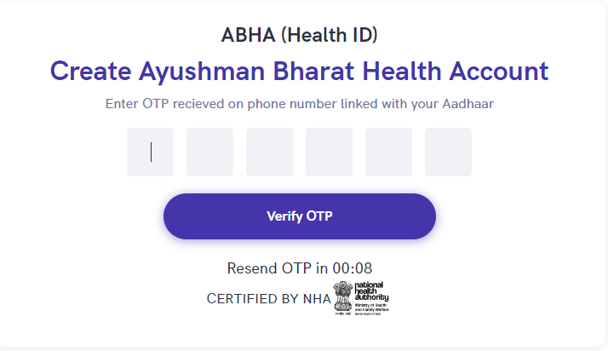

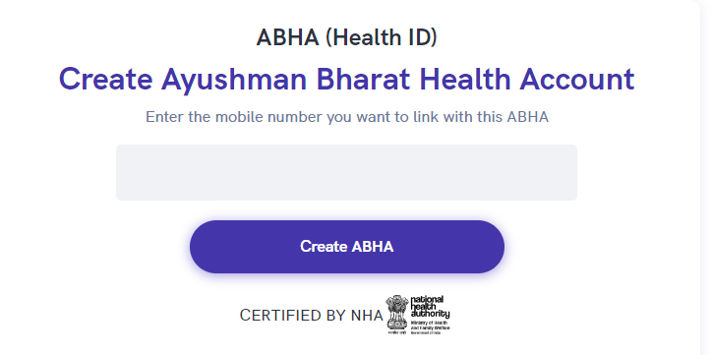

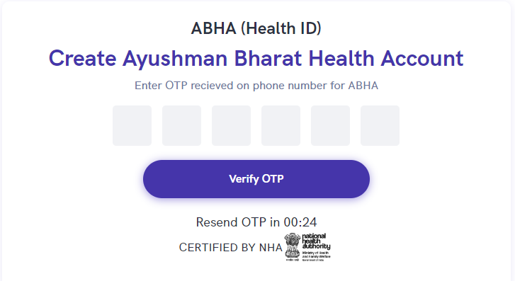

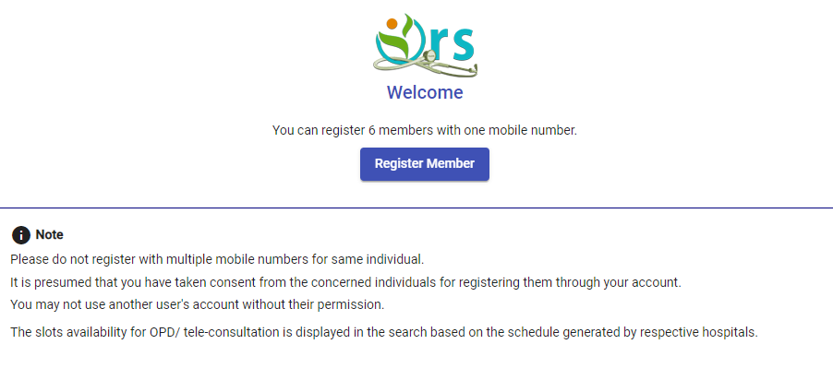
Annexure: Keycloak Identity and Access Management (IAM) Request and Response formats

